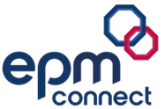
Adding a New Employee
(Non-Teaching Staff)
EPM Connect Guide

Document Control
Document Overview: This document outlines the step-by-step process for adding a new non-teaching employee to EPM Connect.
Classification: Public
Document ID: EPMC007
Author: Lauren McGuire, Product Manager, Product Management
Version: 2.1
Date of Last Review: 27th April 2026
Last Reviewed by: Keren Prior, Director of Operational Excellence
Date of Next Review: 27th April 2027
Document Approval
The Director of Operational Excellence shall review this guide annually and shall determine whether any further changes need to be made prior to approval.
This document was approved by Keren Prior, Director of Operational Excellence on 23rd October 2025 and is issued on a version-controlled basis under her signature.
Document History
Date of Change | 27th April 2026
Summary of Change | Changes to Add a Job Role and Salary Information sections.
New Version Number | v2.1
Changes to be notified to | Director of Operational Excellence

Contents
Add a new employee 4
Personal Information 7
Qualifications 8
ID & Other Checks 8
Pre-employment Checks 8
Payslips & Statements 9
Employee Documents 9
Add Document 8
Add Signable Document 10
View Signable Documents 12
Audit Trail 14
Employment Record 15
Add Job Role 16
Job Information 18
Effective date 18
Job History 18
Basic Job Details 18
Contract Information 20
Work Pattern 20
Absence Approver Tags 21
Salary Information 22
Additions and Deductions 25
Add a new addition 26
Amend a current addition 26
Pension 27
Job Documents 28
Add Document 28
Add Signable Document 29
Add Signatory 30
View Signable Documents 31
Probation 34
Tasks 35

Add a new Employee
All current employees will be added during implementation. However, any new employees can be added to the module either as individual employees via Add Employee or en masse via Import Employees.
Important
The first seven tabs relate to the employee as a whole. In order for EPM to manage payroll and HR effectively, the fields within Personal Information should be completed.
The seven tabs displayed within the lower half of the page relate to the specific job role selected within the Select Job Role drop-down menu.
Once Personal information has been completed you will need to Add a job and then complete the Job Information tab, Salary Information tab and where relevant the Additions and Deductions tab.
The information within the remaining tabs is not required, however we recommend completing as much of this information as possible in order to maximise reporting and analytics.
Add new employee
- On the left-hand side of the EPM Connect window, click Employees. A list of further menu options is displayed.
- Click Details. A list of further menu options will appear.
- Click Add Employee. A new Create Employee Record page is displayed.
- Complete the employee details.
Title, Forename, Surname, Legal Gender for HMRC, Date of Birth, Marital Status and NI Number are mandatory fields.
User Link
- If the employee is a returning employee, select a user from the Link to Existing User drop-down menu.
Previous and archived employees will be recognised in the system if the email address is the same and can be linked to the previous employee record.
Important
If the employee has already worked within the school or another school within the Trust, please ensure your Payroll Team have been informed, as this may affect their payroll.
- If the employee is not already a user, type an email in the Enter New User Email text box.
The New User Email should be the user’s work email address and unique, i.e. not a group email.
- From the User Groups drop-down menu, select all user groups that apply.
User groups can be used to send tasks to groups of employees and manage bulk actions. User groups are managed by the Implementation Team and a list of user groups can be viewed within the Adding Users and Permissions in EPM Connect Guide.
Pre-Employment Checks
ID, DBS and Right to Work checks are mandatory for employees and will automatically appear as checks to be completed within the Pre-Employment Checks section. You can select from any of the additional checks listed and also speak to your Implementation Team should you need any additional checks to be added.
- Within the Pre-Employment Checks section, click the + - button. The section expands.

- Select the checks which should be considered for this employee.
Only checks selected will appear within the Pre-Employment Checks section of the Employee Record.
Should you need any additional checks not listed, please speak to your Implementation Team.
Employment Record
In the Employment Record section, Employment Start Date is a mandatory field for Payroll integration.
Once a Start Date is added this employee becomes a New Starter within Payroll. Once Start Date and Payroll Link have been processed by the payroll, they will become non-editable fields.
- In the Start Date field, select a start date.
- From the Payroll Link drop-down menu, select the property.
Payroll link options will display all payrolls available within this property/school, for example ABC Academy Support or ABC Academy Teaching.
Important
This field must be completed. If the Payroll Link field is not completed the employee will not be included in the Payroll. This applies to Payroll customers only.
- In the End Date field, select an end date if known/applicable.
This should only be used for Fixed Term contracts.
- From the Employment Type drop-down menu, select Employee or Off-Payroll Worker.
This applies to Payroll customers only. Off-Payroll Worker applies to anyone with an IR35.

New Starter Declaration
Important
Please note that although this section must be completed, the manual New Starter Checklist form or P45 should still be sent to your EPM Payroll Team via our Client Communication Platform.
If you are not a Payroll customer, this section must still be completed. However, if you would prefer not to disclose this information, please select Unknown.
- Select the New Starter Declaration that applies.
- Click Save to finish.

The Edit Employee page is displayed with the employee’s Personal Information.
If an Existing, former or archived employee check screen appears double check the details.
If no match is found, click on Save to continue. The employee record is created.
If a match is found, click Cancel to abandon this task and find the employee by selecting the relevant employee within All Employees tab within the Main Navigation Pane. To find the employee within archived or previous employees and see the Archived and Previous Employees section within the Employees Guide.
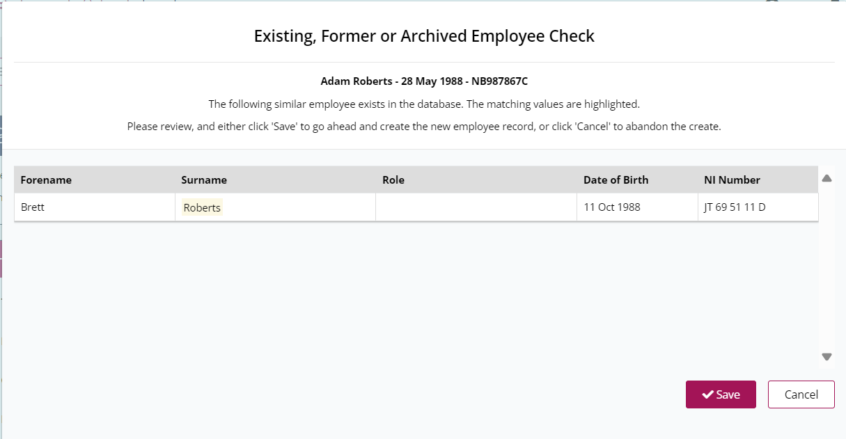

Important
If you are unsure, please do not proceed until this has been checked, as this may result in a duplicate being added to the system
HR Admin Customers
Once the employee has been added, a number of tasks will be created for the school and your EPM HR Admin Team. Please view our Guide to Contracts and Letters.

Personal Information
Only those fields denoted by an asterisk or specified within this guide or the Show Me How To guides are mandatory.
Important
Do not enter – or N/A against any fields which are not relevant as this will be show within any letters or contracts.
- If you are not already in Edit mode, click the Edit Details button. The page is re-displayed with editable fields.
If adding details for the first time the page will automatically be editable.

- In the Preferred Name field, enter a preferred name if relevant.
- In the Former Name field, enter a former name if relevant.
Important
For HR Admin customers, please ensure that you complete the Former Name field in order for your EPM Team to carry out any pre-employment checks.
- In the Teacher Number field, enter a teacher number.
This field is only relevant to teachers.
- From the Legal Gender for HMRC drop-down menu, select a gender.
Legal Gender for HMRC is a mandatory field for EPM Payroll customers.
- Tick the Key Holder box, if relevant.
- The Generated Employee Payroll No. is automatically generated
- In the Car Registration field, enter a registration number.
- Within the Employee Picture section, click the Select file button.

- Within the Sensitive Information section, click the Show Sensitive Information on the left-hand side.

- Complete the Sensitive Information fields.
Sensitive Information (ED&I data)
Sensitive information includes Ethnicity, Marital Status, Religion, Reasonable Adjustments, Medical Conditions and Allergies. This information will be hidden from users. To view the information, click the Show Sensitive Information button. The Audit Trail will record every instance that this information is viewed, including who and when it was viewed.
Each time the Show Sensitive Information button is clicked, this will appear within the Audit Trail.

- Within the Contact Details section, complete the fields.
​Important
If a line of the address is not relevant leave this blank. DO NOT include - or N/A as these will appear in relevant letters and contracts for HR Essentials customers.
Work Email should not be overwritten.
- Within the Next of Kin section, complete the fields.
Both Contact Details and Next of Kin can be completed by employees within My Portal.
- Click Save to finish.

HR Admin Customers
Once the job has been added, a number of tasks will be created for the school and your EPM HR Admin Team. Please view our Contracts and Letters EPM Connect Guide.
Qualifications
Select the Qualifications tab on the left-hand side of the page. Complete the fields and click Save to finish.
Qualifications are not mandatory but not completing this section may have an impact on HR Admin customers. If the employee is an HLTA, tick the HLTA box.
ID & Other Checks
This section will also display any Other Checks that have been added within Employee Settings.
Select the ID & Other Checks tab on the left-hand side of the page. Complete the fields and click Save.
MODULE TIP
Should a current Driving Licence be necessary for an employee, for example for minibus drivers, you may wish to add a task in Task Management to re-check this ahead of the expiry date.
Pre-employment Checks
Select the Pre-employment Checks tab on the left-hand side of the page. Complete the fields and click Save to finish. You can also add new checks within the Other Checks tab of Employee Settings page. These will appear within ID and Other Checks.
The checks displayed relate to the checks chosen when completing the initial details for Add an employee. However, to add additional checks, tick the box on the far right-hand side of the check. The details for completion are displayed.
ID, DBS and Right to Work checks are mandatory for employees and will automatically appear as checks to be completed.
Payslips & Statements
Payroll Customers: All payslips, P45s and P60s will automatically appear within this section following each month’s payroll. Employees can view payslips within My Payslips and Statement, in My Portal.
Employee Documents
Documents can be to the overall Employee Record within the Employee Documents tab within the general Employee Record.
You are also able to view and upload signable documents.
This section allows you to upload documents and signable documents, which can be shared with the employee and saved within the employee record.
- Select the Employee Documents tab on the left-hand side of the page.
This area allows you to store documents related to the Employee. Documents that relate to specific job roles should be saved within Job Documents tab further down the page.
HR Admin customers
Please upload a copy of the employee’s Application Form within this section.
- Click the Edit Details button. The page will refresh, and the fields will become editable.
If adding details for the first time the page will automatically be editable.

Add Document
- Click Edit Documents.

- Select the Employee Documents tab. The Job Documents page is displayed.
- Scroll down to Employee Documents and click the + Upload Documents button.

- In the Title field, enter the title.
- Click Select file.
- In the Expiry Date field, select a date.
- For non-signable documents tick the Visible to Employee in My Portal box to make the document visible to the employee. If the document will be signable, leave this blank.
- Tick Create a signable document from this file after upload to make the document signable.
- Click the Save button.

- The item will appear within the Documents section and if the Visible to Employee in My Portal box has been ticked, within the employee’s My Documents section.
Add Signable Documents
- Click Edit Details.
- Select the Employee Documents tab. The Employee Documents page is displayed.
- Scroll down to Documents and click the + Upload Documents button.
- In the Title field, enter the title.
- Click Select file.
- In the Expiry Date field, select a date.
This field is not mandatory and usually no relevant.
- Leave the Visible to Employee in My Portal box blank.
This will automatically be made visible to the employee after signing.
- Tick the Create a signable document from this file after upload if you wish to make the document signable.
- Click the Save button. The screen refreshes and new fields appear.

- In the Name field, enter a name.
- In the Message field, enter a message.
This can be over-written with a bespoke message.
- In the Signature Deadline field, select a date.
This must be a future date, not today’s date.
- From the Document drop-down menu, select a document.
- From the HR User Notification drop-down menu, enter the email address of the employee the document relates to.
Selected users will receive an email notification whenever any action has been taken, for example the document has been signed or read.
- From the Choose HR Recipients drop-down menu, select the users that apply.
This should include the employee that the document relates to and if desired, the other signatories. Selected signatories will be able to view this document within My Documents within My Portal.
The recipient is the owner of this document. After users have signed this document, the document will stay attached to the employee profile. If there are multiple recipients, this means that there will be multiple signable instances of this document that will belong to each individual recipient
- Leave the Choose Bureau Recipients field blank.
Add Signatories
Important
The Employer should be added as the first signature. If multiple employers need to sign the document, on behalf of the school or trust, these should be added as subsequent signatories. The Employee should always be the final signatory.
Add Employer Signatories
- Click the + Add Signatory button. A new window is displayed.

- From the HR or Bureau User drop-down menu, select HR User.
- From the Users drop-down menu, select the user that apply.
Select the email address of the user signing on behalf of the school or select Signer Tags.
- From the Signer Tags drop-down menu, select the signer tags that apply.
Signer Tags allow you to set up groups of signatories, for example the Line Manager related to the account or the HR Team.
Signer Tags are set up in Employee Settings.
- From the Approval Condition drop-down menu, select the relevant approach.
Requires signing by All: Requires each user or signer tag to sign the document.
Requires signing by Any: Requires just one user or signer tag to sign the document.
- From the Approval Order drop-down menu, select first.
This will allow the employer to sign first on behalf of the school or Trust. The employee will not be able to view or sign the document until all other signatories have signed the document.
- Click the Save button. The window closes.

- Repeat the process for all additional employee signatories.
Employee Signature
You should now repeat the process for the Employee.
- Click the + Add Signatory button. A new window is displayed.

- From the HR or Bureau User drop-down menu, select an option.
- From the Users drop-down menu, select the employee.
- Leave the Signer Tags field blank.
- From the Approval Condition drop-down menu, select either option.
Either option can be used for employees.
- From the Approval Order drop-down menu, select and option.
Select the next available order, for example if you have already selected First and Second for employers signing on behalf of the trust, select Third.
- Click the Save button. The window closes.

- Click the Save button within the main page.

Send email
- Click the email icon on the far right-hand side of the document listed. A preview of the email is displayed.
This is the email that will be sent to the employee. The email content cannot be changed.
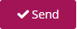
- Click Send.

The document will now be sent to the school signatory to sign. This will appear as a Task within the Task Management Module and within My Tasks within My Portal.
Once this has been completed, it will be sent to the employee to sign.
Once signed by both parties, the document will be visible to the employee within My Documents in My Portal, unless the Visible to Employee box has not been ticked.
If the employee rejects the document, the user who has sent the document to be signed will not be notified. Therefore, ensure you have processes in place to receive feedback and for staff to notify you if they have rejected a document. It may be useful to create a task for yourself as a reminder.
View Signable Documents
These can be viewed by your HR and Admin Teams within the Employee Documents section of the Employees module, not within the Signable Documents section. The Signable Documents section is used only to manage signable documents, not to view them.
Within the Documents section of Employee Documents, click the download icon on the far right-hand side of the document to view the document.
Once a document has been uploaded, either as a standard document or signable document, you will be able to view the details of the document, including whether it is signable and visible to employees. For signable documents you can also view whether the document has been signed and sent for signing.
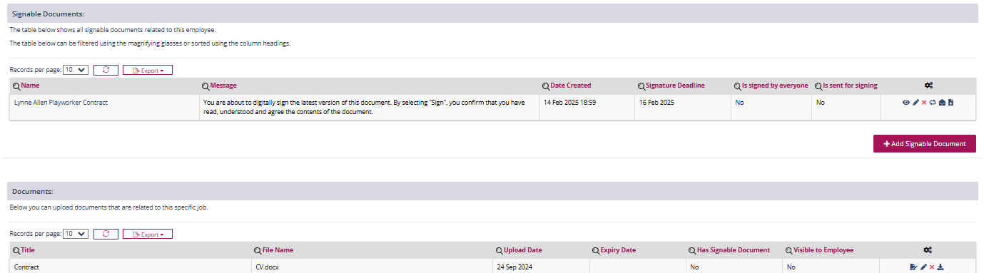

Other actions within Documents
Click this icon to make the document signable. If you have followed the steps above, this is unnecessary, as the document has already been made signable.
Click the pencil icon to edit the document.
Click the cross icon to delete the document.
Click this icon to download the document.
Other actions within Signable Documents
Click the eye icon to view the document, in addition to an Audit Trail for this specific
document and the Recipients and Signatories.
Click the pencil icon to edit the document. Editing the document will remove the signatures.
Click the cross icon to delete the document.
Click this icon to reset the document. This will reset (remove) the signing process and all existing signing data. This is useful if a document has been sent to an incorrect signatory or the wrong document has been sent.
Click this icon to send the document to be signed.
View Signable Document, signatories, recipients and progress
The progress of a signable document can be seen by clicking on the title of a signable document. This will display the Name, Signer Tags, Signing Message, Order, Status, User Type, Signing Condition, Time Read and Time of Signature.
A full Audit Trail of the document can be viewed by clicking on the Audit Trail tab within this section.
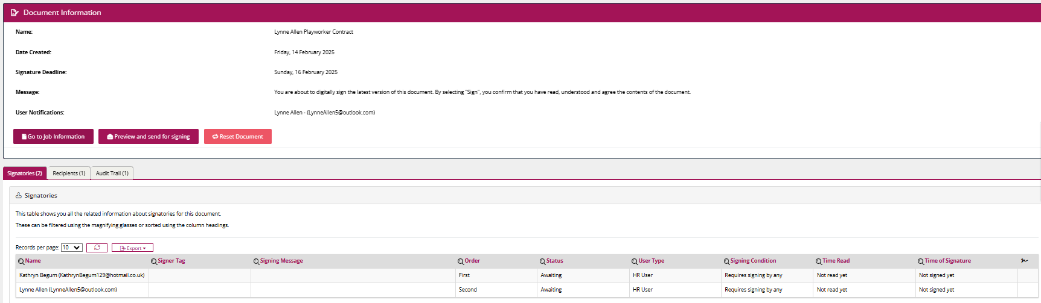

Check the progress of the contract or letter
Once the document has been sent for signing, we recommend checking the progress of the document to ensure that all parties have signed the document, in order to ensure compliance.
- From the left-hand side of the system, select Employees. A list of further options is displayed.
- Select Details. A list of further options is displayed
- Select All Employees.
- In the Employee Search, enter the name of the employee you wish to view. A list of employees matching the search criteria are displayed.
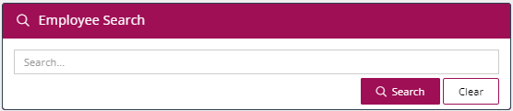

- Click the eye icon on the far right-hand side of the employee you wish to view. The employee record is displayed.
- On the left-hand side of the Employee Details page, from the Select Job Role drop-down menu, select the relevant job role.
- Select the Job Documents tab.

- Click the Edit Details button.

- Check the Is sent for signing column within the data table to ensure the document has been sent.
Yes indicates the document has been sent.
No indicates the document has not been sent.
To send the document, click the email icon next to the relevant document and click Send.
- Check the is signed by everyone column.
Yes indicates the document has been signed by everyone.
No indicates the document has not been signed by all parties.
Click the eye icon and select the Signatories tab to view whether the document has been read and signed by each party.
Click the pencil icon to edit. Editing will remove all signatures from the document.
Click the cross icon to delete the document.
Click the double arrow icon to reset the document. This will remove all signatures.
Click the envelope icon to send the document for signing.
Click this icon to preview the document. The document will appear within your download files.
Click this icon to make the document signable
Click this icon to download the document.
Audit Trail
The Audit Trail tab provides a full audit trail of every action completed against the employee’s file. Click the Audit Trail tab within the tabs displayed on the left-hand side to view a full audit trail.
Every change made to employee records is displayed, with a date and the name of the person who has updated the record. The audit trail relating to signable documents is displayed separately and is not included within the main Audit Trail tab. This audit trail can be viewed within Employee Documents or Job Documents, by clicking on the document title.
Employment Record
Employment Record is pre-configured and should not be edited unless the employee has resigned.
The Generated Employee Payroll No. can be viewed within this section.
The Primary Job Role is the main role held by the employee and the role in which the Bank Details provided against this role will be applied.
Select Employment
The employment record will display the start date of the employee’s employment and if the employee has previously worked at the organisation, will include the option to view their previous employment.
Benefits
Benefits is pre-configured and non-editable.
Please note this will not be visible until the first pay run has been completed for this employee.
Loans
Loans is pre-configured and non-editable.
Attachment Orders
Attachment Orders is pre-configured and non-editable.
Attachment orders include court orders that allow a creditor to take money from a debtor’s salary.

Add Job Role
New job roles can be added to an Employee Record. The tabs under Select Job Role relate to each individual job role. The tabs above Select Job Role relate to the overall employee.
Important
Payroll customers only: When adding a new role you must ensure you add the Primary Role first. The Bank Details associated with this role will inform the bank account that the employees pay is paid into.
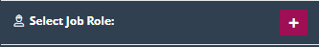
- In the Select Job Role button, click the + button. A new window is displayed.

- From the Post drop-down menu, select a post, or leave as None.
A number of posts can be set up within the Posts section of the Employees module. This is not mandatory, however can be used to create a list of filled and unfilled roles and will automatically populate the Posts Map, providing a useful organisation chart.
Posts are mainly used for customers using the Recruitment module as they are mandatory for creating vacancies.
- In the Job Title field, enter a job title.
- In the Start Date field, enter a start date.
- In the End Date field, enter an end date, if applicable.
This should only be completed for fixed term or temporary contracts and only if the temporary reason does not relate to cover or a named child.
Important
If an End Date is provided, the appointment will end on this date and the appointment will move into Previous Employment. However, if the employee is a leaver, you must manually process the employee as a leaver. We therefore recommend setting a task within Task Management as a reminder. See the Resign Employee within the Employees Module Guide for more information.
- From the Reports To drop-down menu, select the Line Manager.
The Reports To field will determine the standard approver for a variety of actions such as Absence and Expenses.
- From the Department drop-down menu, select a department.
If the department you require is not available, you can raise a request to your EPM Team via our Client Communication Platform.
- From the Job Category drop-down menu, select a job category.
- In the Starter Tasks field, select any starter tasks that apply.
Starter Tasks are common tasks for starters that have been pre-configured in Employee Settings, preventing you from having to create these individually for each employee. Go to Employee Settings to create a variety of starter tasks to choose from.
- Tick the Casual Member of Staff box, if this applies.
Tick this box if the role relates to a casual or zero hours staff. Ticking this box will relax mandatory field requirements around job and salary information in the employee record.
The Add a new Employee – Casual Staff guide within the Resource Centre provides a separate, simplified guide for adding casual employees.
- Tick the Inside IR35 box, if this applies.
Tick this box if this role is inside IR35. IR35 refers to an off-payroll worker. Ticking this box will relax mandatory field requirements around job and salary information in the employee record.
- Tick the Senior Leadership Team box, if the member of staff is a member of the SLT.
- The Continuous Service Start Date field, enter a date.
A suggested date will appear based on the information already entered within the system but can be overridden.
Continuous Service Start date is anything included within the modification order and can include service outside the current organisation (for example roles undertaken within Local Government or the police).
- In the Continuous Service Start Date within Organisation field, enter a date.
A suggested date will appear based on the information already entered within the system but can be overridden.
Continuous Service Start Date within Organisation can be the date that the employee started within your organisation or where applicable with the Local Authority/Trust. The organisation responsible for the employee’s payslip.
- From the Contract Agreement Type drop-down menu, select a contract agreement type.
- If the role is temporary or fixed term, in the Temporary Reason field, enter the reason for the role’s temporary status. For example, Pupil Numbers.
Important
If the temporary reason is related to cover or support role relating to Family Leave or Named Child Support, please enter the word Maternity Cover, Shared Parental Leave Cover, Named Child, Sickness Cover and Adoption Cover within the Temporary Reason.
The reason provided will be included within letters and contracts.
- From the Contract Hour Type drop-down menu, select a contract hour type.

- From the Contract Hour Type drop-down menu, select a contract hour type.
Important
Carefully consider the options. Selecting the wrong option can result in incorrect calculations.
Part Time: 52 week staff working part time hours within this role.
Full Time: 52 week staff working full Time hours within this role.
Part Time Term Time Only: Term Time only staff working part time hours within this role.
Full Time Term Time Only: Term Time only staff working part time hours within this role.
Zero Hours: Casual staff working without set contracted hours within this role.

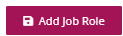
- Click the + Add Job Role button. The window closes and the employee record is displayed.

HR Admin Customers
Once the job has been added, a number of tasks will be created for the school and your EPM HR Admin Team. Please view our Guide to EPM Connect Employees Module Tasks.

Job information
Some of these details will have auto-populated from the information provided within the Add a job screen.
Effective Date
The Effective Date will be pre-set with the employee’s start date. If editing the role, the system will prompt you to select an effective date, once Edit Details has been selected. However, this can also be manually changed once editing the page.
The chosen Effective Date may alter the available options within the drop-down lists, if the settings have been edited between the selected date and today.
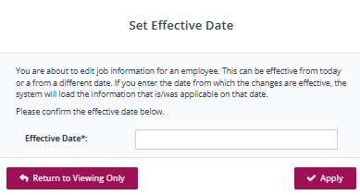

Job History
Click the Job History button to view all previous and current roles recorded within the system.
Click the Job History button to view all previous and current roles recorded within the system.
This will only be relevant for established employees, not when first adding a new role.
This will display salary changes, displayed in order of Effective Date order.
Bold text denotes the employee’s current role.
Basic Job Details
Some of these fields will already be populated from the information you completed when first adding the employee’s details. This guide includes the key information required and does not include pre-populated fields or non-mandatory information.
- From the Type of Post drop-down menu, select a type of post.
This is required as part of the Workforce Census.
- The Entitlement Group field will be populated once the job category is populated. This is a non-editable field.
- From the Account Code drop-down menu, select an account code.
This will be set up by EPM. If the option you need is not displayed, please speak to your EPM Team.
- From the Role Identifier drop-down menu, select a role identifier.
This is required as part of the Workforce Census.
- From the Cost Centre drop-down menu, select a cost centre.
This relates to budget codes and will be set up by the EPM Team within Admin, within Main Settings. If the option you require is not displayed, please speak to your EPM Team.
- Tick the Senior Leadership box only if the employee is a member of the Senior Leadership Team or a Business Manager/Bursar.
This is for reporting purposes.
- In the Job Description field, enter a job description.
- From the Origin drop-down menu, select an origin.
This is required as part of the Workforce Census and describes the employee’s employment or situation prior to this employment.
- In the End Date field, enter an end date if relevant and known.
Important
Clicking within the End Date field will automatically populate today’s date. Do not click in the field unless the role has ended.
- From the Destination drop-down menu, select a destination.
This is only relevant if an End Date has been entered. This is required as part of the Workforce Census and describes the employee’s plan should they have given notice.
- Reason for Leaving should only be completed when an employee leaves this role.
- If the role has ended, enter the Final Holiday Balance.
This should only be completed if the role has ended.
- From the Department drop-down menu, select a department.
- In the Property field, ensure the correct property is selected.
This will default to the property in which you entered the information but can be changed to match the school that the employee is based in.
- From the Reports To drop-down menu, select the relevant email address.
This is the person the employee reports to, i.e. their Line Manager. This will be used in various modules for authorisation purposes where Line Manager has been selected.
- In the Property Arrival Date field, enter the date the member of staff starts/started at the school, not within this role.
For example if the person has recently worked within or currently works within the organisation within another role.
- Tick the Include In The School Workforce Census box, if you wish the employee to be included in the Workforce Census.
This box is ticked as default. If unticked, the role will not be included within the Workforce Census.
Contract Information
- In the Contract Number field, enter a contract number if required.
This refers to the organisation’s internal contract number and will not be automatically populated. This is not a mandatory field.
- In the Paid Leave field enter the number and select from hours or days to confirm paid leave.
This is only relevant non-teaching staff working 52 weeks.
- In the Required Notice Period field, enter a number and select from Days, Weeks, Months or Term.
- Tick the Use Pro-Rata Paid Leave if this applies.
If Pro-Rata Paid Leave is ticked the holiday entitlement will be calculated based on service within the academic year. If this is not ticked, holiday entitlement will not be calculated pro-rata.
Pro-Rata Paid Leave will be configured during implementation and cannot be changed per employee. Should you wish to change this, please speak to your HR Team.
- From the Bank Holiday drop-down menu, select the option that applies.
- From the Override Sick Leave Policy drop-down menu, select the option that applies.
Select the appropriate sickness policy for paid absence from the drop-down list, if this is different to your standard policy. These policies are set up within Employees Settings.
- If using your standard policy, select Not overridden.
- In the Training Requirements field, enter any training requirements or planned training.
This information will appear within contracts created by your EPM Team.
Work Pattern
Work pattern is used to calculate holiday and absences.
Important
Work Pattern information is mandatory.
- From the Working time Lost Measured In drop-down menu, select Days.
This information will be used to measure time lost for absences.

- Click the + Add Shift button. A new window is displayed.

Shifts specify the hours worked each day. If the role has different hours for different days, each set of hours and days they apply to, should be created as a separate shift.
- From the Use a Template drop-down menu, select the option that applies.
Templates can be created within Shift Templates in Employee Settings. This will allow you to create set shift patterns to reduce time taken to set up new employees and job roles.
- From the Week drop-down menu, select the option that applies.
This allows you to create alternating shift patterns where applicable – selecting Week 1 or Week 2. If the shift does not alternate, select No Alternating.
- In the Start Time field, enter a start time.
- In the End Time field, enter an end time.
- In the Hours field, enter the total hours or click the arrow to auto-calculate, based on the Start and End Time provided.
To calculate the number of hours automatically (without any breaks), click the Calculate button.
To specify the number of hours with break times removed, enter the hours in the text box
- From the Type drop-down menu, select All, Term Time or Holiday.
Important
If the employee works less than 52 weeks, this MUST be completed to view the entitlement weeks.
- In the Days field, select the days the employee will work.
Days default to Monday to Friday and are highlighted in pink. Click the days to remove them. When removed these will be greyed out.
- In the Active from field, select the date the shift pattern will begin.
- In the Active to field, select the date the shift pattern will end.
- Click the + Add Shift button to save the shift.

Absence Approver Tags
Here you will select the users who will approve the various absence types, including holiday related to this employee within this particular role. Absence Approver Tags are set up within Absence Settings.
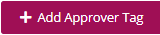
- Click the + Add Approver Tag button. A new window is displayed.

- Tick the approver tag that applies e.g. Jury Duty, Bereavement, Maternity to enable them to approve specified absence reasons (if applicable).

- Click the + Add Absence Approver Tag button. You will return to the main screen.

- Click the Save button to finish.

HR Admin Customers
Once the Job Information has been completed, a number of tasks will be created for the school and your EPM HR Admin Team. Please view our Guide to EPM Connect Employees Module Tasks.
Salary Information must now be completed in order for your EPM teams to manage your monthly HR Admin and Payroll processes.
Salary Information
Protected Weeks – this will not usually apply. If you think this may apply, please contact your HR Team via the chat.
- The Effective Date will be pre-populated. Do not change.
- Move the Enforced Calculation toggle to YES.
Important
Enforce Calculation Method is necessary to auto-calculate fields based on the data you have entered.
A number of fields will be auto calculated once the following fields have been completed:
- Contract Hours
- FTE Hours
- Working Weeks
- FTE Weeks
Basic Pay
Some of the fields are auto populated based on the information you enter. Therefore, you should scroll down to Pay Start Date and begin to enter the information from there.
- In the Pay Start Date field, select a date.
- From the Pay Range field, select a range.
This is the grade and will define the pay points displayed within the Pay Scale field.
- From the Pay Scale field, select a scale.
This is the point. If the pay point you need is not visible you may need to select a different Pay Range.
- In the Contract Hours field, enter the contract hours.
- From the FTE Hours drop-down menu, select the FTE hours.
This is the total amount of hours the employee can work in this role.
- In the Contractual Overtime Hours field, enter the hours worked over the FTE hours.
- In the Contractual Overtime Rate % field, enter the percentage.
- The Contractual Overtime Amount field will auto-populate upon saving and does not need to be entered.
- From the FTE Weeks drop-down menu, select the number of weeks the FTE would work in a year.
This is number of weeks a Full-Time Employee would work in a year, including paid leave.
This is only applicable for non-teaching staff.

- In the Protected Weeks field, enter the number of protected weeks, only if applicable.
This is the number of additional weeks to be added to working weeks to give a guaranteed number per year, for example after TUPE.
This will not apply to most employees. This will only apply if the annual leave that is calculated by the system needs adjusting to match a previous post. This is generally due to errors with previous providers or workarounds required by the school. Speak to your HR Admin Team or Payroll for further advice.
- In the Protected Reason field, enter the reason.
This is a description of the reason for the Protected Weeks, for example to match a TUPE agreement.
- From the Working Weeks drop-down menu, enter the weeks.
This is the number of weeks the employee works in a year.
- In the Paid Over Weeks fields, enter the weeks.
This is the number of weeks the employee is paid over the year and generally reflects the FTE weeks. For example, 39 + 5.6 = 44.6 weeks.
- In the Contract Days field, enter the contract days.
This is the average number of days worked per week. This could be a decimal, for example if working alternative shifts, or some half days per week.
- In the Working Pattern field, please enter the contract hours relating to each day.
Please enter the average hours worked on each day. For example, if an employee works alternating shifts on a Monday - Week 1: 6 hours, Week 2: 4 hours, you will enter 5 hours as the average hours on a Monday.
- The Payroll Number is auto populated and does not need to be completed.
- From the Working Pattern Pro Rata Rule drop-down, select Calendar Days in Period.
Select 365 Rule for Teaching Staff
Select Calendar Days in Period for Non-Teaching Staff.
- The Tax Code field does not need to be completed and is not used by our Payroll Team.
- Tick the Safeguarded Salary box if relevant.
Reasons for Safeguarded Salary may include an employee that has rescinded a TLR or due to a restructure has moved down in points and is receiving their previous salary for an agreed period.
Please speak to your EPM Team about any Safeguarded Salaries before a Pay Award is applied.
In the Protected Reason field, enter the reason.
This is a description of the reason for the Protected Weeks, for example to match a TUPE agreement.

- Tick the Eligible For Pay Progression box if relevant.
This is not a mandatory field.
- The FTE Value will be auto populated for support staff, based on the information entered within other fields.
- FTE Calculation Name – this is a pre-populated, non-editable field.
- FTE Value Calculation Name – this is a pre-populated, non-editable field.
- The Salary field will be auto populated after a Pay Range and Pay Scale have been calculated.
The Salary field will only be editable if the Spot Rate toggle has been changed to YES, otherwise this will be auto calculated.
- The FTE Salary field will be auto populated. Do not overwrite.
- Daily Rate will be auto populated for teachers. Do not overwrite.
- Hourly Rate is automatically populate based on the other salary fields completed. This should not be changed.
- Move the Spot Salary to YES or NO.
If the rate does not exist within the system, or is not a standard scale for the job category, select YES.
Leadership Pay
- Tick the Leadership Pay box if relevant.
This is for reporting purposes.
- From the Pay Framework drop-down menu, select the pay framework.
This relates to the agreed pay scales and is for reporting purposes.
- In the Pay Range Minimum field, enter a minimum.
Enter the minimum possible salary for this grade.
- In the Pay Range Maximum field, enter a minimum.
Enter the minimum possible salary for this grade.
Agency Staff
This section does not need to be completed and will not affect payroll; however, it may be useful to tick the Agency Staff box for reporting purposes so that you can choose to exclude agency staff.

Bank Details
- Complete the employee’s bank details.
This can also be updated by the employee within the Salary information section of My Profile, in My Portal as part of our self-service feature.
Important
The Bank Details should be recorded against the main role held by the employee. Thie is displayed within the Primary Job Role field within the Employment Record section of the Employee’s Record.
This can also be updated by the employee within the Salary information section of My Profile, in My Portal as part of our self-service feature.
Payroll customers: Please ensure you inform your EPM payroll team should you receive a notification that Bank Details have been changed by an employee after the Payroll Cut Off Date.
View Salary History
To view the salary history of the employee related to this job role, click the View Salary History button.
This will only be relevant for established employees, not when first adding a new role.
This will display salary changes, displayed in order of Effective Date order.
Bold text denotes the employee’s current role.
Red denotes a Temporary Change.
Blue denotes a Temporary Change Reversed.

Additions and Deductions
Additions and Deductions relating to the employee are displayed within this section.
Important
Deductions cannot be added within this section. These are managed by your EPM Team. If you wish to add/amend/delete a deduction, please send a request via the EPM Client Communication Platform.
Current additions should not be deleted as this may result in previous payments made in relation to this addition being reclaimed via payroll. Amendments to additions should be made via an amendment to the current addition or a by adding a new line.
Add a new addition
- Click the + Add Addition button.
- From the Addition Settings Title drop down, select the relevant option.
If the title you require is not available, speak to your EPM Team.
- From the Full Time Amount drop-down menu, enter an amount or click the Use Default button to auto-calculate the amount.

- In the Payment Start Date field, select a start date.
- In the Payment End Date field, select a start date.
- In the Reason field, enter a reason.
Although not mandatory, the Reason field is used to populate content in letters and contracts. If not populated, the document will require the user to manually add a reason.
- Tick the Is this payment a bonus box if relevant.
- Click Save.

Amend a current addition
Current additions should not be deleted as this may result in previous payments made in relation to this addition being reclaimed via payroll. Amendments to additions should be made via an amendment to the current addition or a by adding a new line.
To correct a current addition (where previous payments relating to this addition have already been made), follow the Correct a current addition guide below.
To amend information to a current addition (where previous payments relating to this addition have already been made), follow the Create a new line guide below. The new line will supersede the previous line based on the start date and will automatically create an end date for the current line based on this date.
Correct a current addition
Correcting the current addition if previous payments have been made may result in previous payment made in relation to this addition being reclaimed via payroll. If you do not wish for this to happen, do not edit the current addition but instead add a new line.
- Click pencil icon next to the addition you wish to amend.
- Click the pencil icon to amend the relevant line.
- Amend the details as appropriate.
- Click Save.

Create a new line
The new line will supersede the previous line based on the start date and will automatically create an end date for the current line based on this date.
- Click pencil icon next to the addition you wish to amend.
- Click the + Add Line button.

- From the Full Time Amount drop-down menu, enter an amount or click the Use Default button to auto-calculate the amount.

- In the Payment Start Date field, select a start date.
- In the Payment End Date field, select a start date.
- In the Reason field, enter a reason.
Although not mandatory, the Reason field is used to populate content in letters and contracts. If not populated, the document will prompt the user to manually add a reason.
- Tick the Is this payment a bonus box if relevant.
- Click Save.
The new line will replace the previous addition after the start date.
Pension
This section is non-editable and will be completed by your Payroll & Pensions Team.

Job Documents
This section allows you to view and upload documents to the employee’s record in relation to the Job Role selected. You are also able to view and upload signable documents.
You can view and upload documents related to a specific role within the Job Documents tab within the general Job Record.
This section allows you to upload documents and signable documents, which can be shared with the employee and saved within the employee record.
Click this icon to make the document signable.
Click the pencil icon to edit the document.
Click the cross icon to delete the document.
Click this icon to download the document.
- Select the Job Documents tab on the left-hand side of the page.
This area allows you to store documents related to the specific role selected. Documents that relate to the overall employee should be saved within Employee Documents tab further up the page.
- Click the Edit Details button. The page will refresh and the fields will become editable.
If adding details for the first time the page will automatically be editable.

Add Document
- Scroll down to Employee Documents and click the + Upload Documents button.
- In the Title field, enter the title.
- Click Select file.
- In the Expiry Date field, select a date.
- For non-signable documents tick the Visible to Employee in My Portal box to make the document visible to the employee. If the document will be signable, leave this blank.
- Tick the Create a signable document from this file after upload if you wish to make the document signable.
- Click the Save button.

- The item will appear within the Documents section and if the Visible to Employee in My Portal box has been ticked, within the employee’s My Documents section.

Add Signable Document
- Click Edit Details.
- Select the Employee Documents tab. The Employee Documents page is displayed.
- Scroll down to Documents and click the + Upload Documents button.
- In the Title field, enter the title.
- Click Select file.
- In the Expiry Date field, select a date.
- Leave the Visible to Employee in My Portal box blank.
This will automatically be made visible to the employee after signing.
- Tick the Create a signable document from this file after upload if you wish to make the document signable.
- Click the Save button. The screen refreshes and new fields appear.

- In the Name field, enter a name.
- In the Message field, enter a message.
This can be over-written with a bespoke message.
- In the Signature Deadline field, select a date.
This must be a future date, not today’s date.
- From the Document drop-down menu, select a document.
- From the HR User Notification drop-down menu, enter the email address of the employee the document relates to.
Selected users will receive an email notification whenever any action has been taken, for example the document has been signed or read.
- From the Choose HR Recipients drop-down menu, select the users that apply.
This should include the employee that the document relates to and if desired, the other signatories. Selected school signatories will be able to view this document within My Documents in My Portal.
The recipient is the owner of this document, this means that after users have signed this document, the document will stay attached to the employee profile. If there are multiple recipients, this means that there will be multiple signable instances of this document that will belong to each individual recipient
- Leave the Choose Bureau Recipients field blank.

Add Signatory
Important
The Employer should be added as the first signature. If multiple employers need to sign the document, on behalf of the school or trust, these should be added as subsequent signatories. The Employee should always be the final signatory.
Add Employer Signatories
- Click the + Add Signatory button. A new window is displayed.

- From the HR or Bureau User drop-down menu, select HR User.
- From the Users drop-down menu, select the user that apply.
Select the email address of the user who will be signing on behalf of the school. Alternatively select Signer Tags.
- From the Signer Tags drop-down menu, select the signer tags that apply.
Signer Tags allow you to set up groups of signatories, for example the Line Manager related to the account or the HR Team.
Signer Tags are set up in Employee Settings.
- From the Approval Condition drop-down menu, select the approach that applies for document to be classed as approved.
Requires signing by All: Requires each user or signer tag to sign the document.
Requires signing by Any: Requires just one user or signer tag to sign the document.
- From the Approval Order drop-down menu, select first.
This will allow the employer to sign first on behalf of the school or Trust. The employee will not be able to view or sign the document until all other signatories have signed the document.
- Click the Save button. The window closes.

- Repeat the process for all additional employee signatories.
Employee Signature
You should now repeat the process for the Employee.
- Click the + Add Signatory button. A new window is displayed.

- From the HR or Bureau User drop-down menu, select an option.
- From the Users drop-down menu, select the employee.
- Leave the Signer Tags field blank.
- From the Approval Condition drop-down menu, select either option.
Either option can be used for employees.
- From the Approval Order drop-down menu, select and option.
Select the next available order, for example if you have already selected First and Second for employers signing on behalf of the trust, select Third.
- Click the Save button. The window closes.

- Click the Save button within the main page.

Send email
- Click the email icon on the far right-hand side of the document listed. A preview of the email is displayed.
This is the email that will be sent to the employee. The email content cannot be changed.
- Click Send.

The document will now be sent to the school signatory to sign. This will appear as a Task within the Task Management Module and within My Tasks within My Portal.
Once this has been completed, it will be sent to the employee to sign.
Once signed by both parties, the document will be visible to the employee within My Documents in My Portal, unless the Visible to Employee box has not been ticked.
If the employee rejects the document, the user who has sent the document to be signed will not be notified. Therefore, ensure you have processes in place to receive feedback and for staff to notify you if they have rejected a document. It may be useful to create a task for yourself as a reminder.
View Signable Documents
These can be viewed by your HR and Admin Teams within the Employee Documents section of the Employees module, not within the Signable Documents section. The Signable Documents section is used only to manage signable documents, not to view them.
Within the Documents section of Employee Documents, click the download icon on the far right-hand side of the document to view the document.
Once a document has been uploaded, either as a standard document or signable document, you will be able to view the details of the document, including whether it is signable and visible to employees. For signable documents you can also view whether the document has been signed and sent for signing.
Other actions within Documents
Click this icon to make the document signable. If you have followed the steps above, this is unnecessary, as the document has already been made signable.
Click the pencil icon to edit the document.
Click the cross icon to delete the document.
Click this icon to download the document.

Other actions within Signable Documents
Click the eye icon to view the document, in addition to an Audit Trail for this specific document and the Recipients and Signatories.
Click the pencil icon to edit the document. Editing the document will remove the signatures.
Click the cross icon to delete the document.
Click this icon to reset the document. This will reset (remove) the signing process and all existing signing data. This is useful if a document has been sent to an incorrect signatory or the wrong document has been sent.
Click this icon to send the document to be signed.

View Signable Document, signatories, recipients and progress
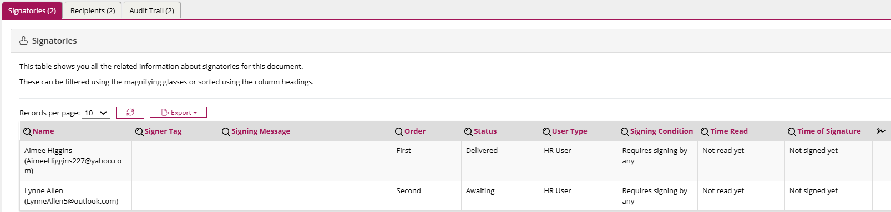
The progress of a signable document can be seen by clicking on the title of a signable document. This will display the Name, Signer Tags, Signing Message, Order, Status, User Type, Signing Condition, Time Read and Time of Signature. Progress is also recorded within the Audit Trail tab.

Check the progress of the contract or letter
Once the document has been sent for signing, we recommend checking the progress of the document to ensure that all parties have signed the document, in order to ensure compliance.
- From the left-hand side of the system, select Employees. A list of further options is displayed.
- Select Details. A list of further options is displayed
- Select All Employees.
In the Employee Search, enter the name of the employee you wish to view.

- Click the eye icon next to the employee you wish to view. The employee record is displayed.
- On the left-hand side of the Employee Details page, from the Select Job Role drop-down menu, select the relevant job role.
- Select the Job Documents tab.
- Click the Edit Details button.

- Check the Is sent for signing column within the data table to ensure the document has been sent.
Yes indicates the document has been sent.
No indicates the document has not been sent.
To send the document, click the email icon next to the relevant document and click Send.
- Check the is signed by everyone column.
Yes indicates the document has been signed by everyone. No indicates the document has not been signed by all parties.
Click the eye icon and select the Signatories tab to view the progress of the document.
Click the pencil icon to edit. Editing will remove all signatures from the document.
Click the cross icon to delete the document.
Click the double arrow icon to reset the document. This will remove all signatures.
Click the envelope icon to send the document for signing.
Click this icon to preview the document. The document will appear within your download files.
Click this icon to make the document signable
Click this icon to download the document.
Probation
Probation information is not mandatory but not completing this section may have an impact on HR Admin customers. HR Admin customers should ensure all relevant sections are completed.
- Select the Probation tab within the Employee Record.
- Click the Edit Details button.

- In the Probation Length field, enter a number and select from Days, Weeks or Months. The Probation End Date is automatically updated.
- In the Probation Meeting Frequency field, enter a number and select from Days, Weeks or Months.
- Tick the Passed box if the employee has passed their probation.
- Tick the Extension box if the probation should be extended.
- If the probation has been extended, in the Length of Extension field, enter a number and select from Days, Weeks or Months.
- Tick the Include Holidays in Probation Length box if this applies.
- Click the Save button to finish.
Incomplete probation information will appear within the Probation tab within Incomplete Records.
Add Probation Meeting
- Click the + Add Meeting button.
- In the Expected Date field, enter the date you expect the meeting to take place.
- In the Meeting Date field, enter the date the meeting took place.
This date can be updated after the meeting has taken place.
- In the Meeting Number field, enter the number, i.e. 3 for the 3rd meeting.
- In the Notes field, add any relevant notes.
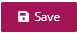
- Click Save.

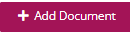
- Click + Add Document to add a relevant document.

- In the Title field, enter a title.
- Click Select file to upload a document.
- Click + Upload Document to save the document.
- Click Save.

Tasks
Tasks can be created within the Tasks tab of the Employee Record. These can be bespoke tasks specific to the employee, or Task Templates, set for all starters. Tasks can also be added within the Task Management module. The tasks displayed here relate to the specific job role selected. For all general employee tasks refer to Task Management Summary.
View and edit tasks
- Select the Tasks tab within the Employee Record. The tasks related to this role are displayed.
- Click the Edit Details button.

- From the Select Job Role drop down, select the job role relating to the tasks you wish to create.
- Click the pencil icon to edit the task.
- Update the information and click the Save button to finish.
Add task
You can either add a new task or add a task from a template.
- Click the + Add Task button. A new window is displayed.

- In the Task Title field, enter a title.
- In the Description field, enter a description.
- From the Assign To drop-down menu, select the person you wish to assign the task to.
The task can be assigned to both the employee you are viewing and other relevant employees.
- From the Assign To User Group drop-down menu, select the user groups you wish to assign to.
- In the Due Date From Start Date field, enter a number and select from Days or Weeks.
- Tick the One or Many Tasks box if you wish for each of the assigned users to complete the task. If this box is left unticked, only one of the users must complete the task for it to be marked complete.
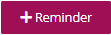
- Click the + Reminder button to set a reminder for the user(s).

- In the Title field, enter a title.
- In the Description field, enter a description.
- In the Notify before Due Date field, enter a number and select from Days or Weeks.
- Tick either or both Notify by Email and Notify by Popup boxes.
- Click the Save button. The window closes.
- Click the Save button to finish.

Add task from Template
- Click the + Add Tasks from Template button. A new window is displayed.
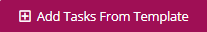
- From the Templates to Apply drop-down menu, select all templates to apply. These are configured within Employee Settings.
- Click the Save button to finish.

