

EPM User Guide
Portal

Contents

EPM Portal
Logging In
The EPM Portal is available at epm-portal.co.uk
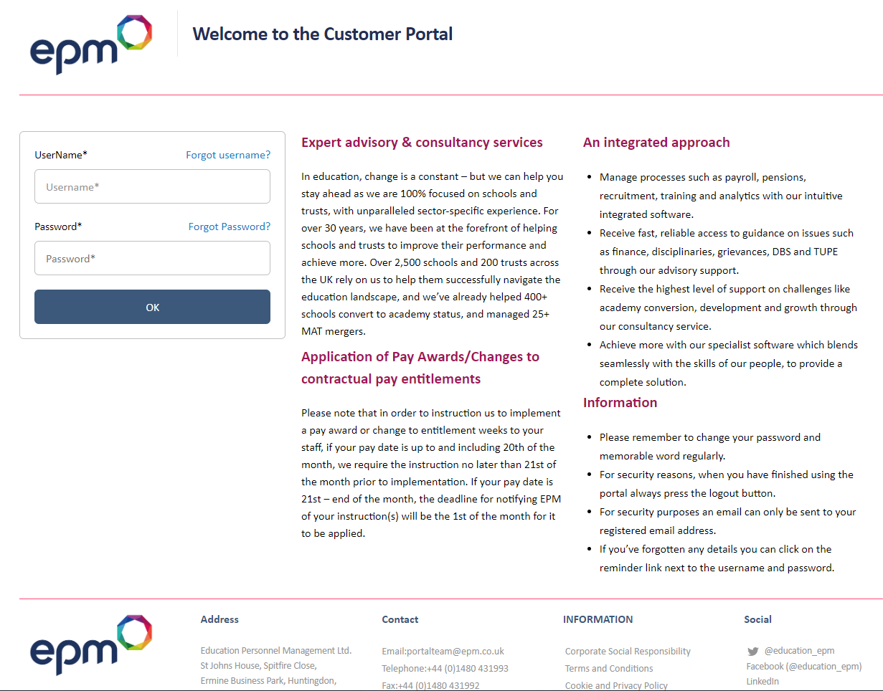
From the Log In Screen you are able to log in to your account.

Multi-Academy Trust Log In
If you are logging in as a user with oversight of multiple academies within a trust you will be presented with a list of the academies you have authorised access to.
Click on the school number to view details of a particular academy. This will take you to the specific academy’s home page.
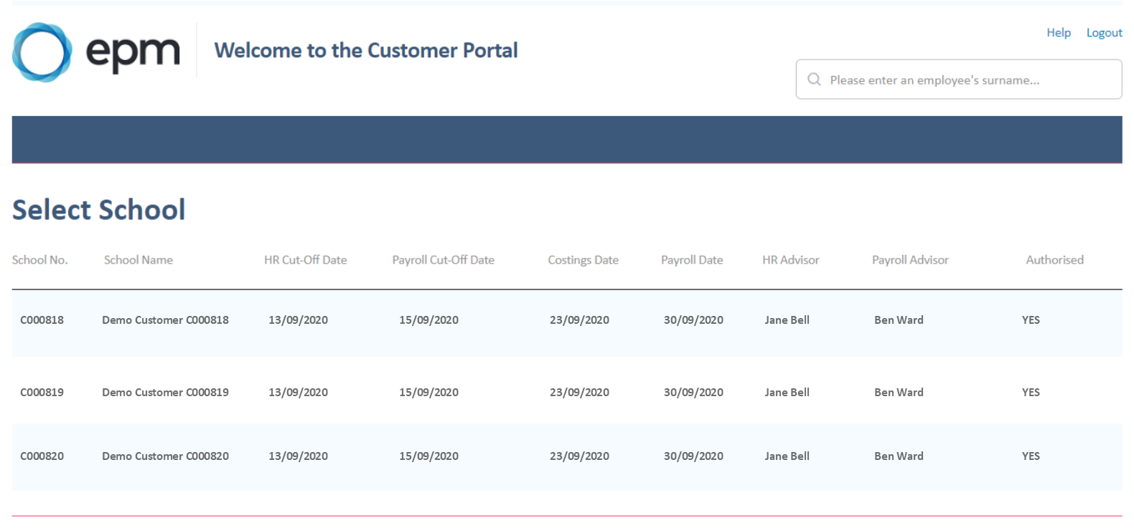


EPM Portal Tabs Overview
My Home Page
Select My Home Page or the EPM logo to return to the home page, where the following information can be found:
- School details
- EPM contact details
- HR and Payroll cut off dates
- Upcoming contract changes for the term such as temporary appointments, hours and allowances that are due to end, maternity and sickness cover posts and employees on unpaid or maternity leave.
- Status of HR instructions that have been entered, e.g. whether they are pending, have been processed by EPM or are still in draft format and have not yet been submitted to EPM.
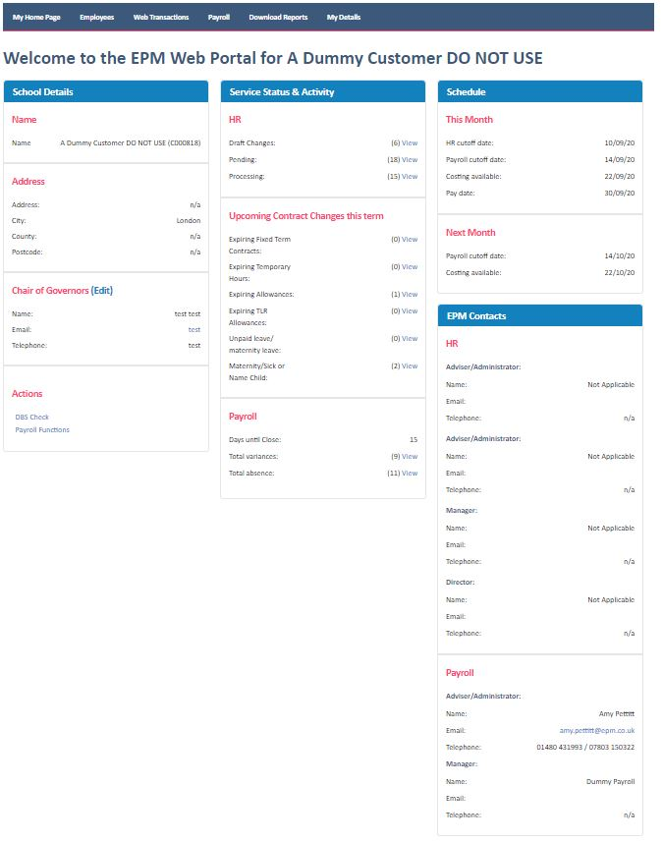

Employees
Select this to display a menu with the following options:
- Create Employee
- List/Amend
- Staff Increments
Web Transactions
A list of any instructions sent to EPM via the portal can be viewed in Web Transactions. From here you can view the status of any instructions:
- Draft – you have saved a draft copy of an instruction, this has not been submitted to EPM.
- Pending – the instruction has been received by EPM and is pending review and process.
- Processed – the instruction has been processed and is available to be included in Payroll.
- Completed – the instruction has been finalised and documentation has been sent.
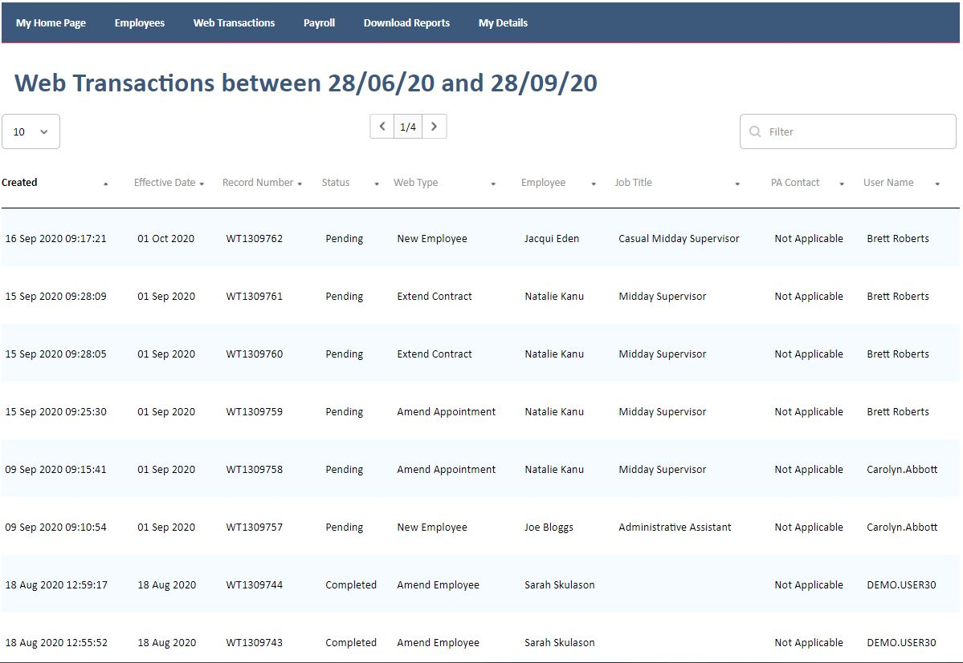

Payroll
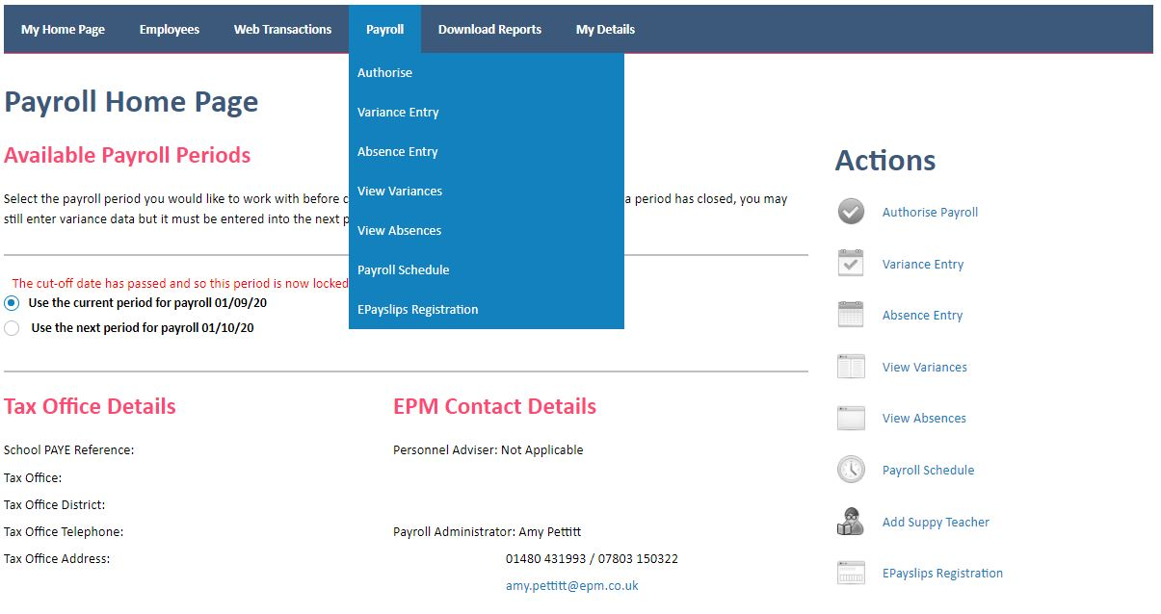
Select this to access the payroll functions, including ePayslip registration, adding variances and absences.

Download Reports
A number of reports are available to download directly from the portal, including staff lists, leavers reports, payroll reports, payslips and many more. For multi-academy trust (MAT) users, we have MAT reports to allow you to see information for all the academies within the trust.
See Appendix A for examples.
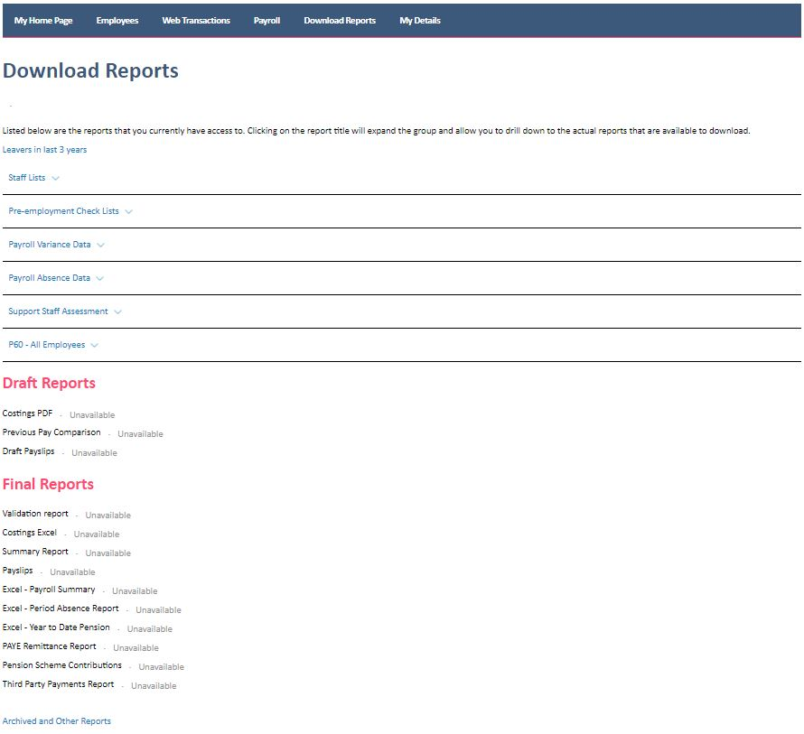

Archived and Other Reports
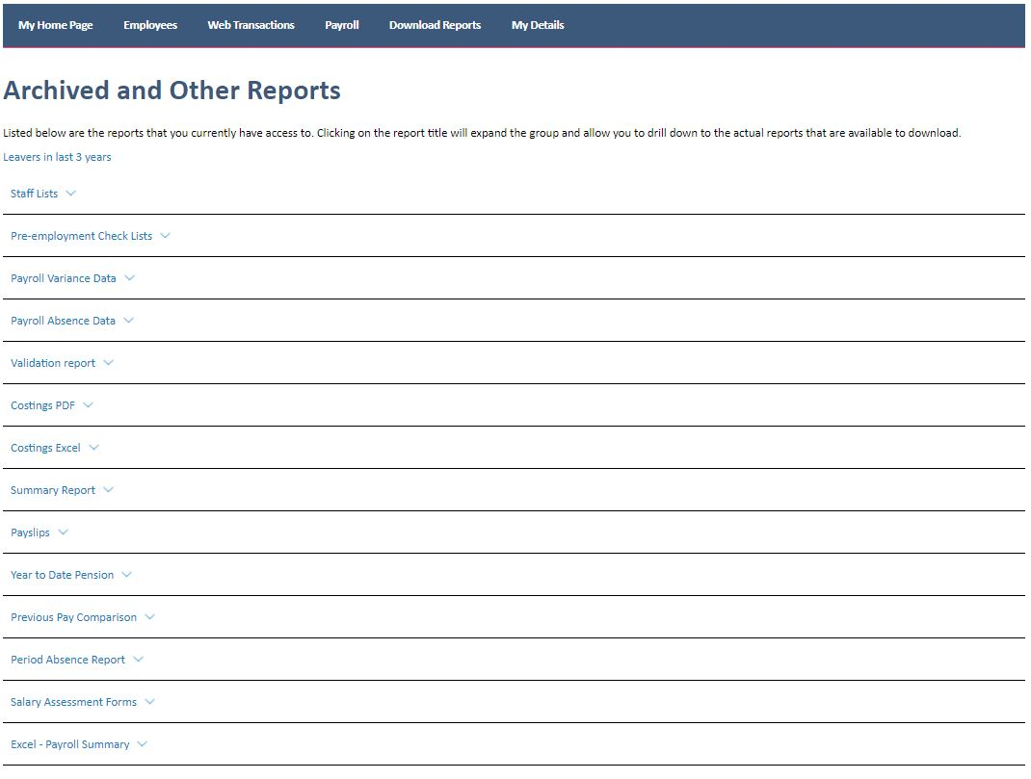
Historical reports can also be accessed via the Download Reports function.

My Details
Select this to display a menu with the following options:
- Change Password
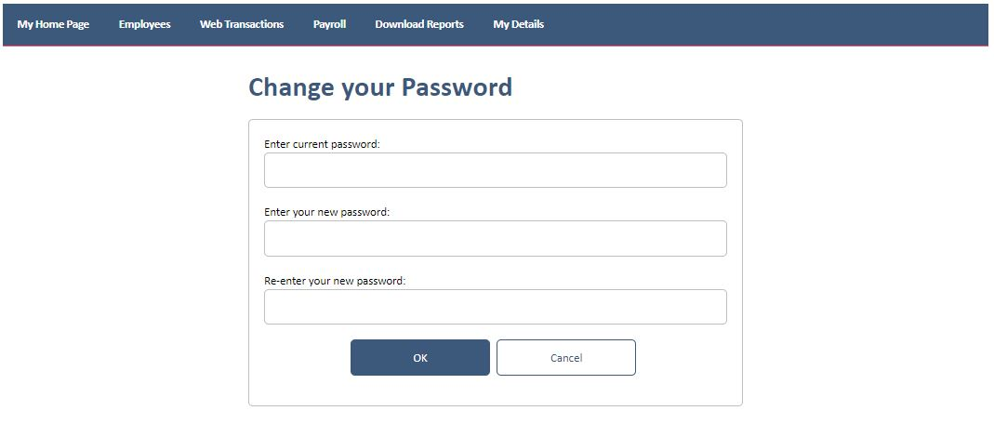
- Change Memorable Word

EPM Portal Entry Guidance
Create New Employee
When you add a new employee via the portal you will follow a simple step-by-step process to add the employee’s personal information as well as the details of the new appointment.
Under Employees tab select Create Employee.
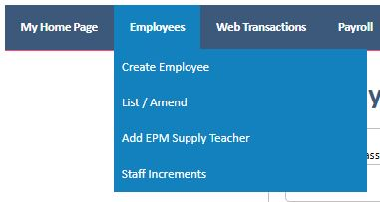

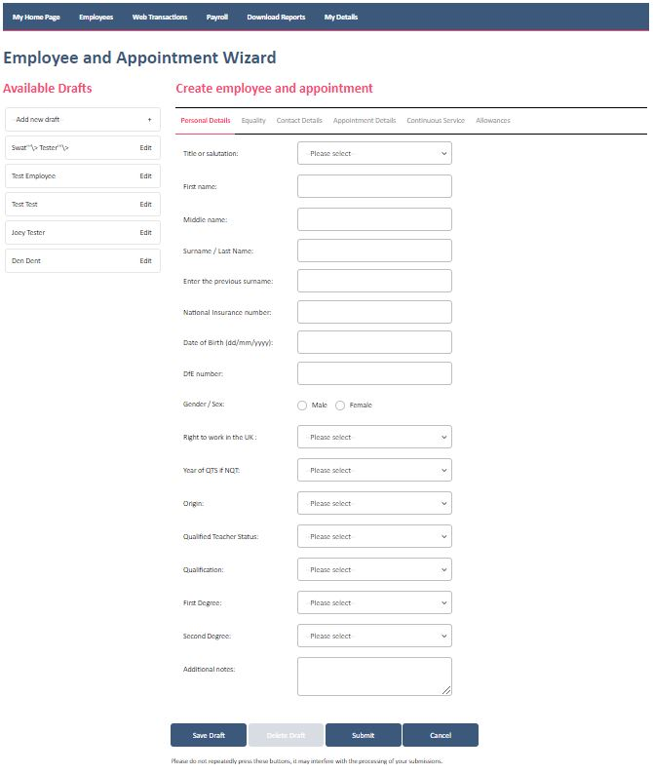
The following six tabs will appear:

Personal Details:
Use this tab to add the personal data for the employee. This information should be found on the employee’s application form. The DfE number, also referred to as Teacher Reference Number (TRN), can be found on a teacher’s qualification certificate. It is vital that personal details are entered correctly as this has implications for pre-employment checks and pensions reporting that we carry out on your behalf.
Equality
Use this tab to add the employee’s equality data. Such as, Religion or Belief, Sexual Orientation, Personal Relationship, Disability and Primary Ethnic Origin.
Contact Details:
Use this tab to add the contact information and bank details for the employee.
Appointment Details:
Use this tab to add the details of the employee’s appointment. Information in many of the drop-down list boxes is populated depending on the option selected previously, e.g. the list available in the Job Family drop-down box will differ according to the selection made in the Appointment Type drop-down box.
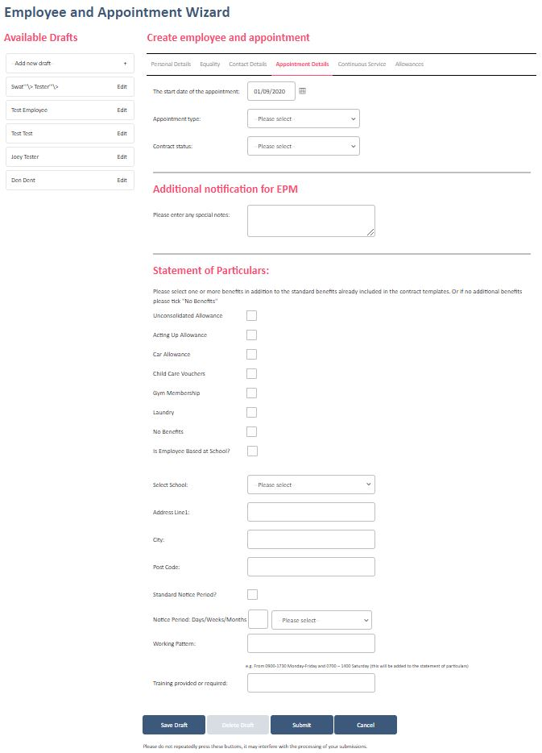

Continuous Service:
If continuous service dates for the employee are unknown, select the Continuous service not known check box. If continuous service dates are known please type the dates in the relevant text boxes.
- Current employer date: this is the date that the employee has been continuously employed by the same employer.
- Local government date: this is the date that the employee has been continuously employed by any employer covered by the Redundancy Payments (Continuity of Employment in Local Government, etc.) (Modification) Order 1999.
EPM will check continuous service dates as part of their pre-employment checks. In order for this to take place, please ensure a copy of the employee’s application form is sent to the EPM HR Contact.
Allowances:
Use this tab to add any allowances. A drop-down list of allowances will be available to select from. If the allowance has an end date there is a box to input this. Type the gross annual figure for the allowance in the text box.
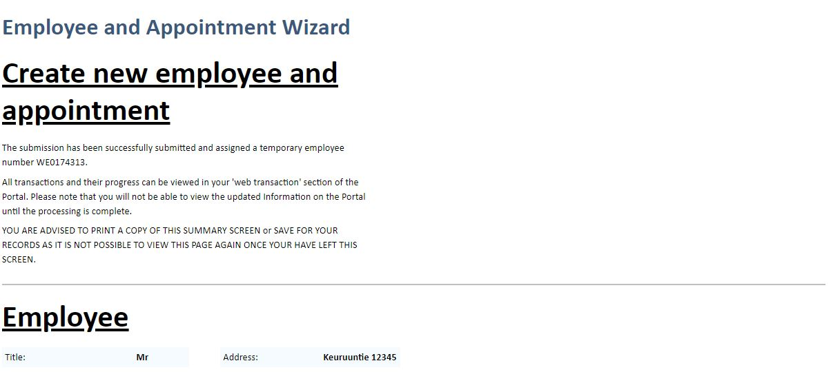
Select Submit once the instruction has been completed.

A summary screen will appear showing you details of the instruction that has been submitted. You are advised to print a copy of the summary screen or save for your records as it isn’t possible to view this page again once you have left this screen.

Employee Search Functions
You can select a specific employee in one of two ways:
- Type the employee’s name in the search box at the top of the screen.
- From the Employees menu, select List/Amend then select the employee from the list displayed. This list can be filtered by employee number/first name/surname/NI no/date of birth, etc.
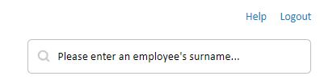

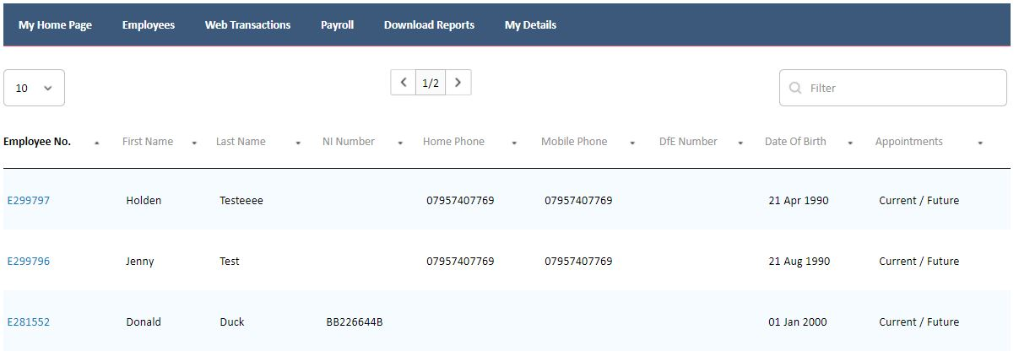

To view an employee’s details, click on the employee number for the employee. The Employee Details and Appointments tabs will be displayed. By selecting the Appointments tab you will be able to view a list of all appointments for the selected employee, including past and future. You can make changes to current and future appointments.
Amend Employee Details
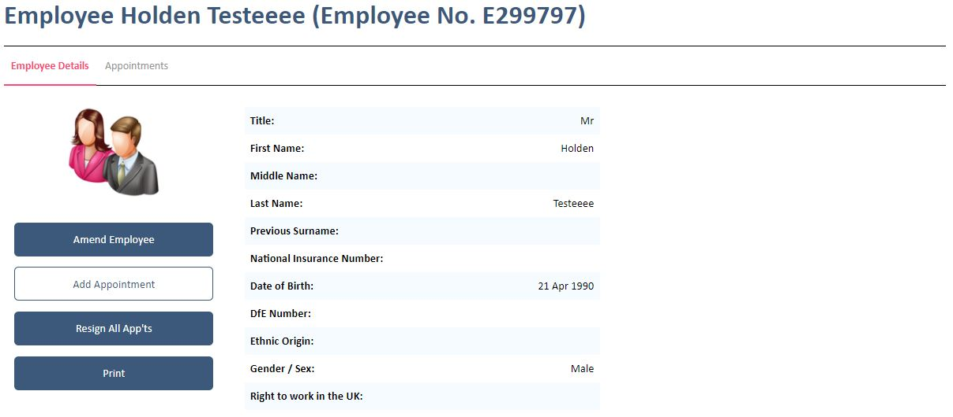
Search for the employee as detailed under Employee Search Function.

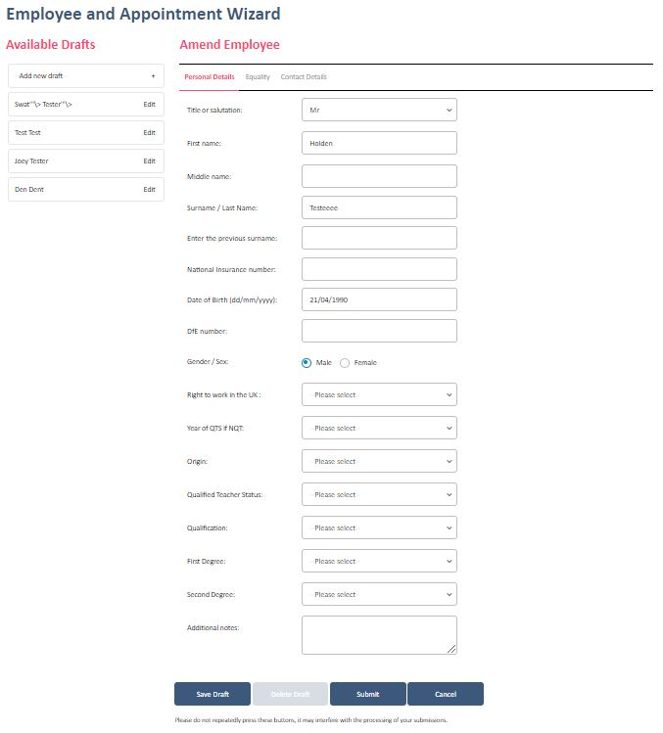
When the employee details are displayed select Amend Employee on the left-hand side of the screen. The Employee and Appointment Wizard will appear where personal, contact and bank details can be amended.

Select Submit once the instruction has been completed. A summary screen will appear showing you details of the instruction that has been submitted. You are advised to print a copy of the summary screen or save for your records as it isn’t possible to view this page again once you have left this screen.
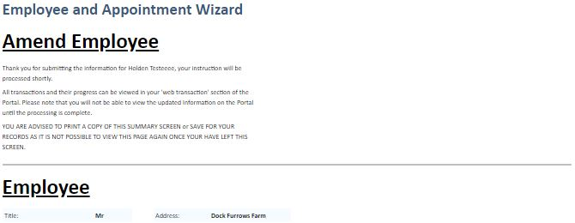

Amend Appointment
Search for the employee as detailed under Employee Search Function.
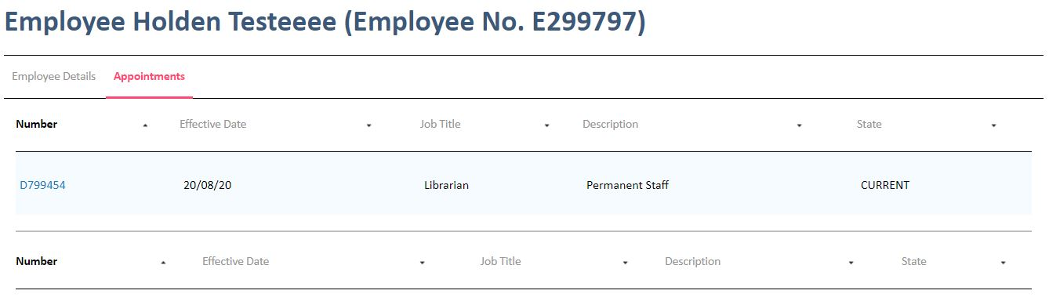
When the employee details are displayed click the Appointments tab. Select the appointment that is being amended by clicking on the appropriate number under the current appointments. If the employee has more than one current appointment they will all be listed here.

Select the Amend button on the left-hand side of the screen.
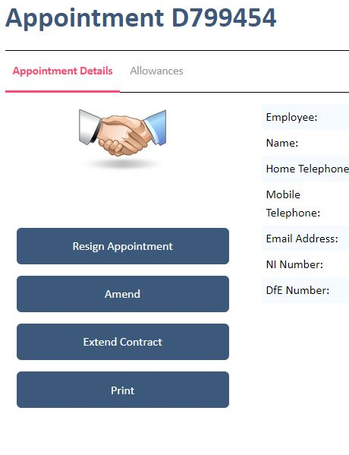

The Amend Appointment Wizard page is displayed. From this screen you can make the required changes to an employee’s appointment using the drop-down lists available.
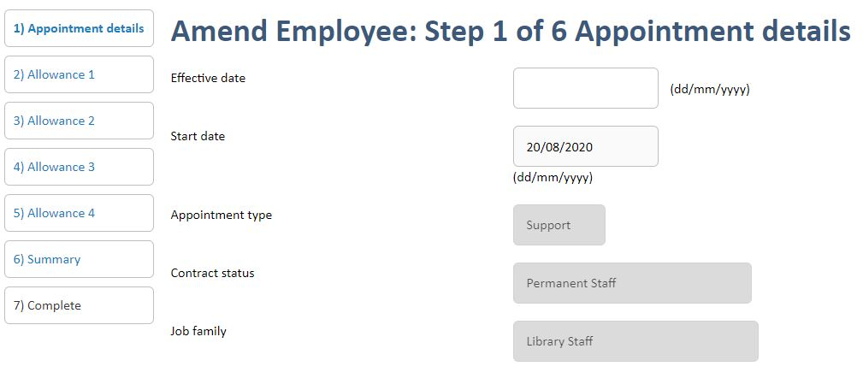

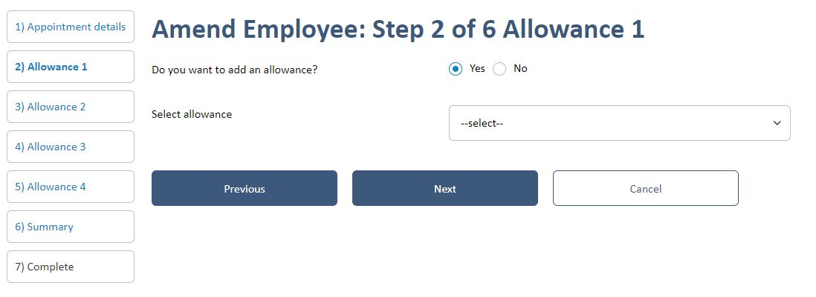
Before completing the transaction you can review any changes you have made. If any details have been entered incorrectly you can select Previous and make further changes.

If you are happy with the summary details select Finish. Your instruction will be sent directly to your assigned EPM Administrator. A further screen will appear confirming the details of the instruction and that your instruction has been successfully submitted. You are advised to print a copy of this summary screen or save for your records as it isn’t possible to view this page again once you have left this screen.
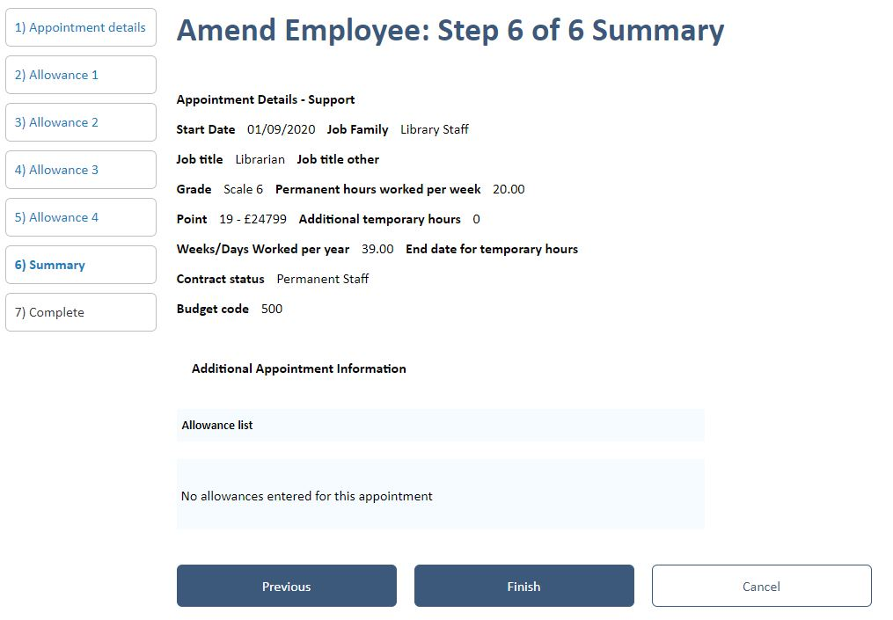

Add New Appointment
Search for the employee as detailed under Employee Search Function.
When the employee details are displayed select Add Appointment on the left-hand side of the screen. The Employee and Appointment Wizard will appear.
Enter appointment details. Please refer to Create New Employee guidance if unsure.
Select Submit once the instruction has been completed. A summary screen will appear showing you details of the instruction that has been submitted. You are advised to print a copy of the summary screen or save for your records as it isn’t possible to view this page again once you have left this screen.

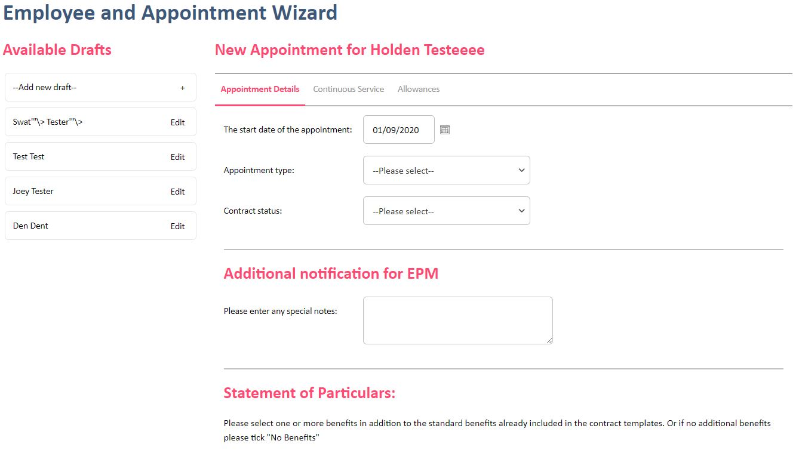

Resign an Appointment
Search for the employee as detailed under’ Employee Search Function’.
When the employee details are displayed click the Appointments tab. Select the appointment that is being resigned by clicking on the appropriate number under the current appointments. If the employee has more than one current appointment they will all be listed here

Select the Resign Appointment button on the left-hand side of the screen. The Resign a Contract page is displayed. This page should be used for ending all appointments whether the resignation is voluntary or compulsory.

Enter the last day of employment in the Effective Date of Resignation text box.
Select the reason for termination of the contract from the drop-down list box.

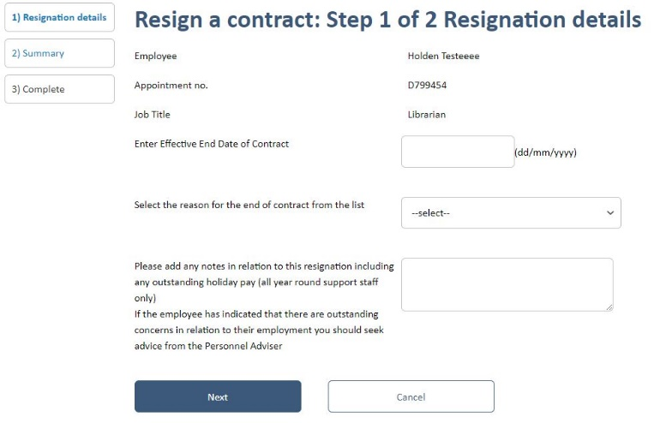

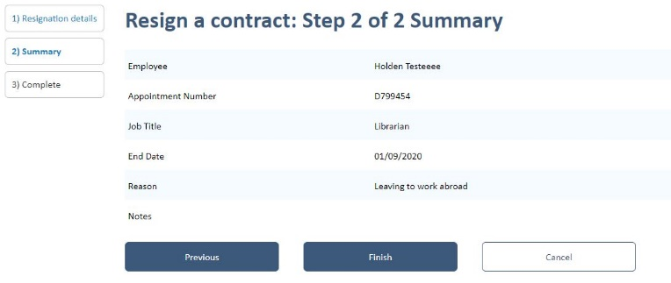
Select Submit once the instruction has been completed.
A summary screen will appear showing you details of the instruction that has been submitted. You are advised to print a copy of the summary screen or save for your records as it isn’t possible to view this page again once you have left this screen.

Resign All Appointments
Search for the employee as detailed under Employee Search Function.
When the employee details are displayed select Resign All App’ts on the left-hand side of the screen. The Employee and Appointment Wizard will appear.
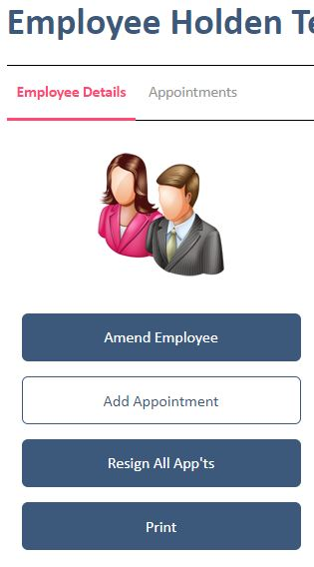

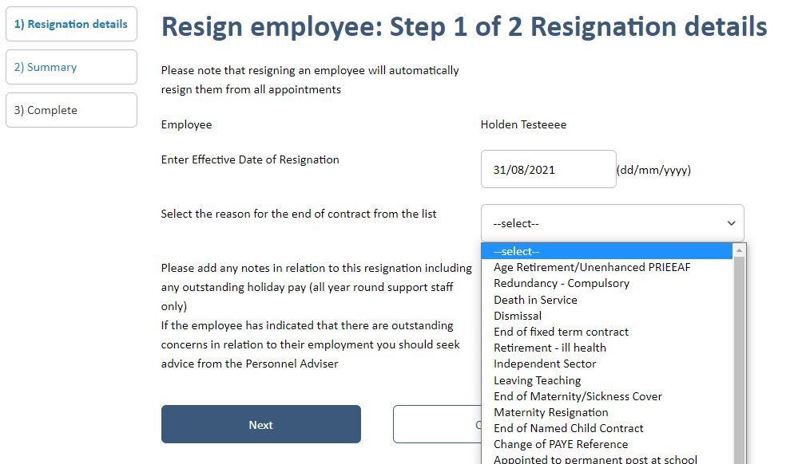
Enter the last day of employment in the Effective Date of Resignation text box.
Select the reason for termination of the contract from the drop-down list box.

Select Submit once the instruction has been completed. A summary screen will appear showing you details of the instruction that has been submitted. You are advised to print a copy of the summary screen or save for your records as it isn’t possible to view this page again once you have left this screen.

Extend Temporary Fixed Term Appointment
Search for the employee as detailed under Employee Search Function.
When the employee details are displayed click the Appointments tab. Select the appointment that is being amended by clicking on the appropriate number under the current appointments.
When the employee details are displayed, click on Extend Contract button on the left-hand side of the screen. The Extend/Make Permanent Wizard is displayed.
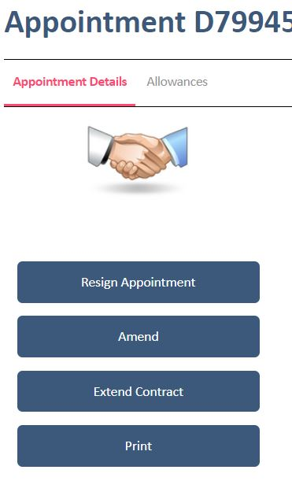

In the Effective Date text box, type the date the change is effective from.
From the Contract Status drop-down list box, select Temporary - Fixed Term.
In the End Date text box, type the revised end date for the contract.
Please note that if an employee has worked the full term, up to and including the last day, they are entitled to be paid to the end of the school holiday period.
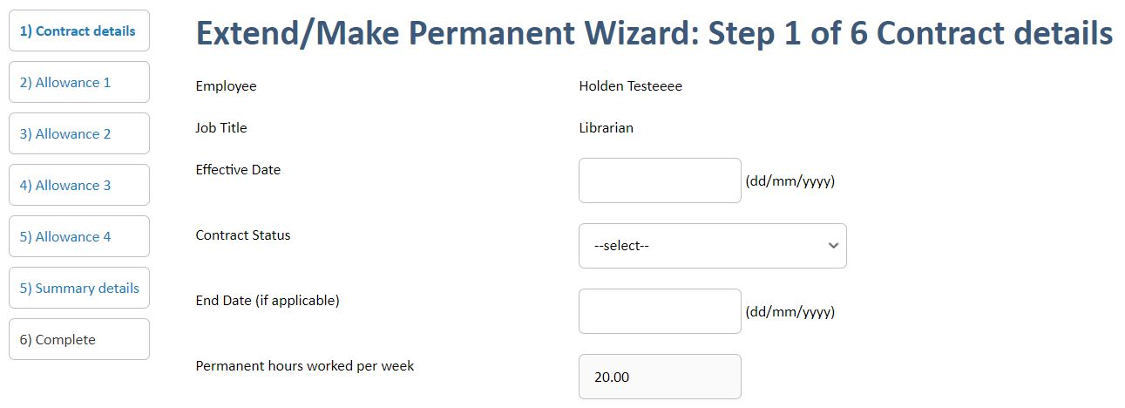
Select Submit once the instruction has been completed. A summary screen will appear showing you details of the instruction that has been submitted. You are advised to print a copy of the summary screen or save for your records as it isn’t possible to view this page again once you have left this screen.

Make Temporary Fixed Term Appointment Permanent
Search for the employee as detailed under Employee Search Function.
When the employee details are displayed click the Appointments tab. Select the appointment that is being amended by clicking on the appropriate number under the current appointments.
When the employee details are displayed, click on the Extend Contract button on the left-hand side of the screen. The Extend/Make Permanent Wizard is displayed.

In the Effective Date text box, type the date the change is effective from.
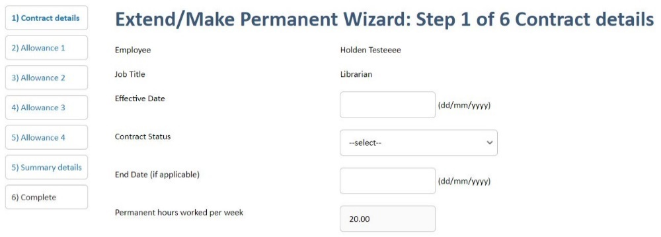
From the Contract Status drop-down list box, select Permanent.
If the employee is currently on a maternity or sickness cover contract and they are moving to a permanent post, the current appointment must be ended and a new permanent appointment submitted rather than changing the status of the current post to permanent.
Select Submit once the instruction has been completed. A summary screen will appear showing you details of the instruction that has been submitted. You are advised to print a copy of the summary screen or save for your records as it isn’t possible to view this page again once you have left this screen.

Payroll Home Page
For customers whose contract includes the Payroll & Pensions service, various payroll transactions can be made via the portal.
Access this page by clicking on the Payroll menu. From this page different pay periods can be selected, payroll variances such as overtime or mileage payments can be entered, employee absences can be added as well as viewing relevant payroll data. If you have any queries, please contact your Payroll Administrator.
From the payroll homepage you can access:

Available Payroll Periods
This section displays information about the payroll periods that are available to work with. If the deadline for this month has passed and the current period is locked, changes can be made for the following month by selecting Use the next period for payroll.
Tax Office Details
This section displays the tax office and PAYE information for the school.
EPM Contact Details
This section displays information for the primary HR and Payroll contacts for the school.

Variance Entry
Select Variance Entry from the Payroll menu or click on Variance Entry on the Payroll Home Page.
To find a specific employee, type the employee name in the Search text box.
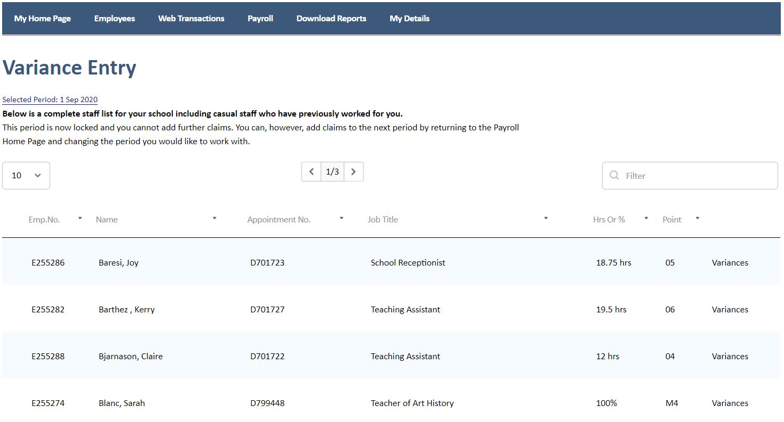
To add a variance, click on Variances at the end of the employee details.
The variance screen will appear. Select the variance to be paid from the drop down list under Variance Type.
Note:
- Please enter the hours to be paid when adding overtime and casual claims.
- Please enter the amount to be paid when entering mileage.
- Casual employees are entitled to holiday pay. Please inform your payroll contact whether you pay statutory or contractual holiday pay.
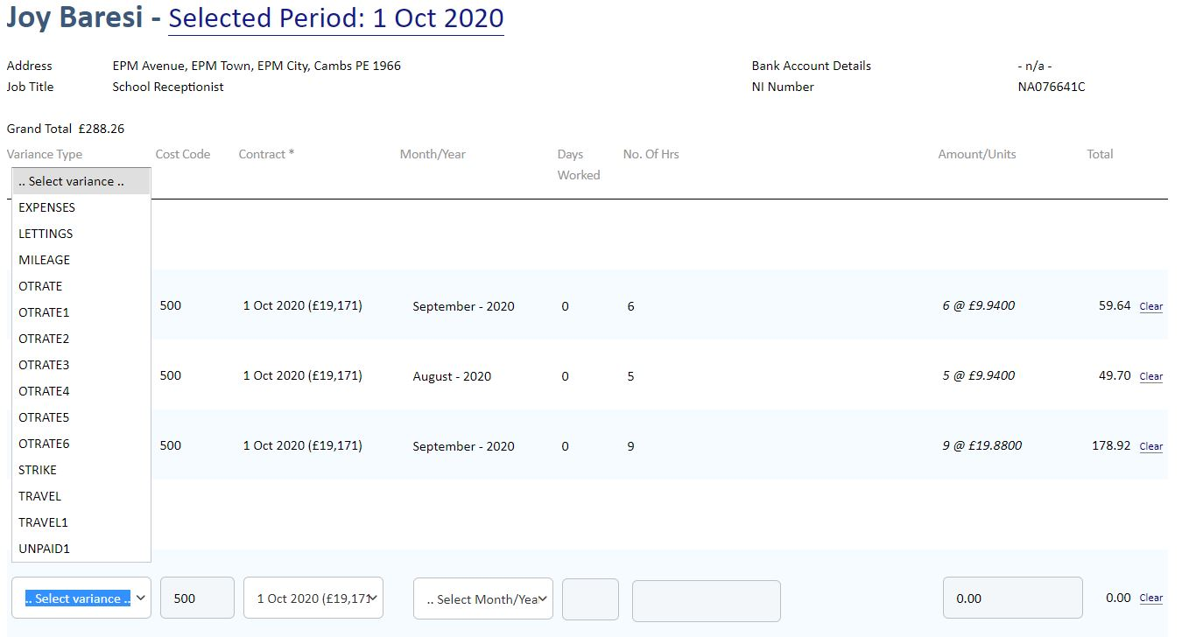

Select Save once the instruction has been completed.

Absence Entry
Any employee absence should be recorded such as paid sickness, maternity, paid leave and unpaid leave, etc. If the type of absence isn’t available for you to select you can add a note detailing the reason for the absence.
Select Absence Entry from the Payroll menu or click on Absence Entry on the Payroll Home Page.
Select employee from the drop down list. Absence can be recorded for either a day or a period. To record a half day absence, select the day and add a note to advise that this needs to be recorded as half a day.
The whole period of absence needs to be recorded rather than just the working days of the employee. For example, if any employee is absent from Tuesday to Monday but only works Tuesdays and Thursdays, the absence for the whole period needs to be recorded, including weekends.
Select Save once the instruction has been completed.
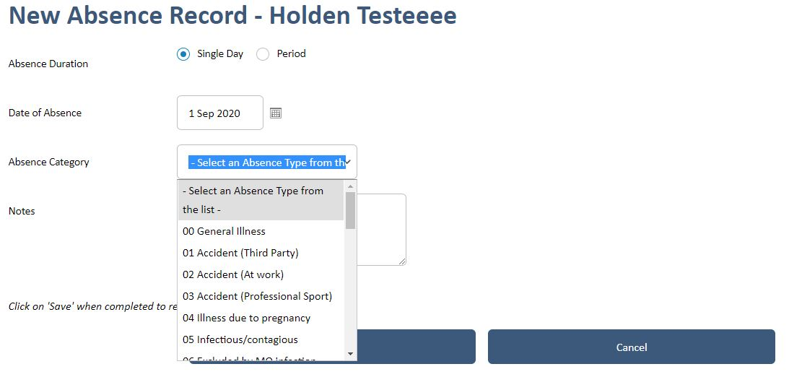

View Variances
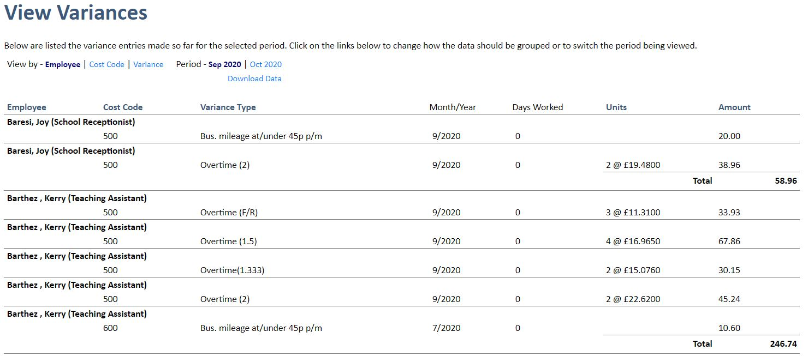
This allows variances to be viewed that have been added to the current pay period. Details of variances added can be sorted by employee, cost codes and type of variance. The data can also be downloaded into Excel for ease of use.

View Absences
This allows absences to be viewed that have been added to the current pay period. Details of absences added can be sorted by employee, cost codes and type of variance and the data can be downloaded into Excel for ease of use.
You also have the option of a calendar view of absences for a specific employee.
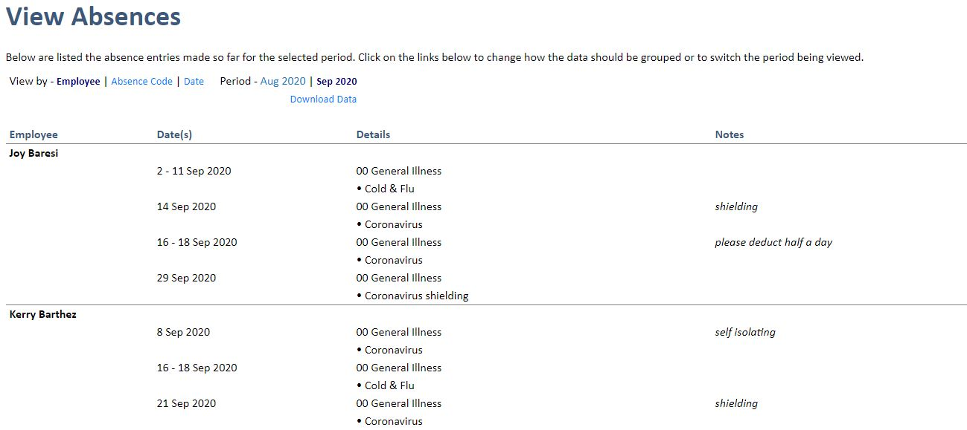

Payroll Schedule
You can view the payroll schedule for the financial year. From here you can see deadlines for:
- Adding any variances via the Portal (‘Payroll Cut-off’)
- Cut off dates for each pay period
- Date that the costings report will be available
- Date that payroll needs to be authorised by
- Pay date for that month
Please note that the HR deadline is 48 hours prior to the variance cut-off date on the payroll schedule.
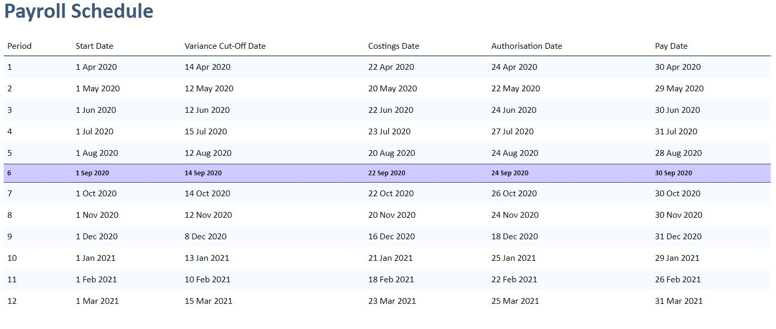

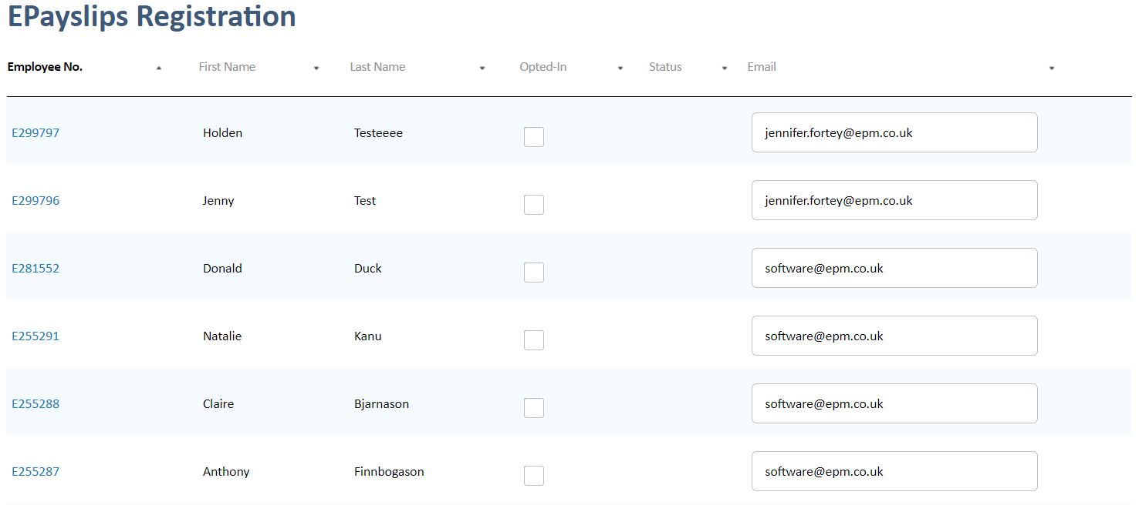
ePayslips Registration

For guidance on ePayslips, please see our:
- Frequently Asked Questions
- Single Sign-on Guide
- Introduction to EPM’s Self-Service Functionality Video

Useful Tips
Below are some useful tips on how to use the portal. If an entry is submitted in error please let your EPM contact know who can remove or cancel the entry for you. If in doubt about how to enter an instruction, please do not hesitate to get in touch with your EPM team who will be happy to assist you.
Additional Notification to EPM
If you are unsure whether you have submitted the instruction correctly or want to add a note to the instruction you can enter this in the additional notification to EPM box. There is a 250 word limit so if you require more than this please send your EPM contact an email with the details.
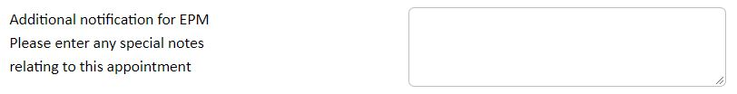
Personal Details
Please ensure that the correct personal details are entered on the portal. Include all previous surnames as these will be required when carrying out Barred List Checks and sending details to pensions. Please include the NI number on the portal instruction if this has been provided.
It is vital that personal and appointment details are entered correctly as this has implications for pre-employment checks and pensions reporting that we carry out on the school’s behalf.
Current Employees Appointed to New Posts
If an employee has been appointed to a new post, rather than amending the details of the current appointment, please ensure a new appointment is submitted via the portal. Please then resign the previous appointment with the reason Promotion in School. This alerts EPM that the employee is not leaving the school and a P45 will not be issued in error. Please ensure the new appointment is added first in order to avoid inputting all the personal details again.
Employees Transferring to another School within a Trust
Where an employee is moving to another post within the trust, please ensure that the resignation reason is recorded as Transfer within Multi-Academy Trust. This alerts EPM that the employee is not leaving the trust. The school that the employee is transferring to needs to add the details of the new appointment.
Deadlines
Please be aware of the HR and Payroll deadlines. Any changes made before the deadline dates are guaranteed to be processed for that month. However, if any instructions come in after this date, although EPM will always try to accommodate any late changes, we cannot guarantee that these will be processed in time for the current month’s payroll and may have to wait until next month.
The payroll portal will lock down at midnight on deadline day. Once this has occurred, no further variances, absences, etc., can be submitted for that pay period. They can continue to be added to the next pay period.
The HR portal doesn’t lock down at any point. Instructions can continue to be submitted at any time regardless of the month the change affects.

Sickness Absence
Please ensure sickness absence information is entered on the portal in a timely matter so that EPM can calculate sick pay and alert the school if the employee is due to drop in pay. Late entries may mean that half and no pay dates are missed, resulting in the employee being overpaid.
Honorarium, Recruitment and Retention Allowances
Honorarium allowances can only be awarded to support staff.
Recruitment and retention allowances can only be awarded to teachers. These allowances are time limited and require an end date to be entered on the portal.
Accessing the Leadership Pay Spine for Employees who are not SLT
For any employees who are not SLT but need to be paid on the leadership pay spine, e.g. Coordinators or Heads of Subjects, select the Assistant Headteacher job family. There will be a blank box where the actual job title can be input.
Temporary Fixed Term Appointments
An end date and genuine temporary reason should be submitted for any temporary fixed term appointments.
Maternity and Sickness Cover Appointments
These appointments do not require an end date but the name of the person being covered must be entered.
Pay Calculations
Deductions for Industrial Action
- Teachers are deducted across all payrolls as per the Burgundy Book guidance as salary / 365 for each day.
- Support staff are salary / 260 for each day on a 5 day week.

DBS Portal
Logging In
The DBS Portal is available at https://epm.disclosures.co.uk/
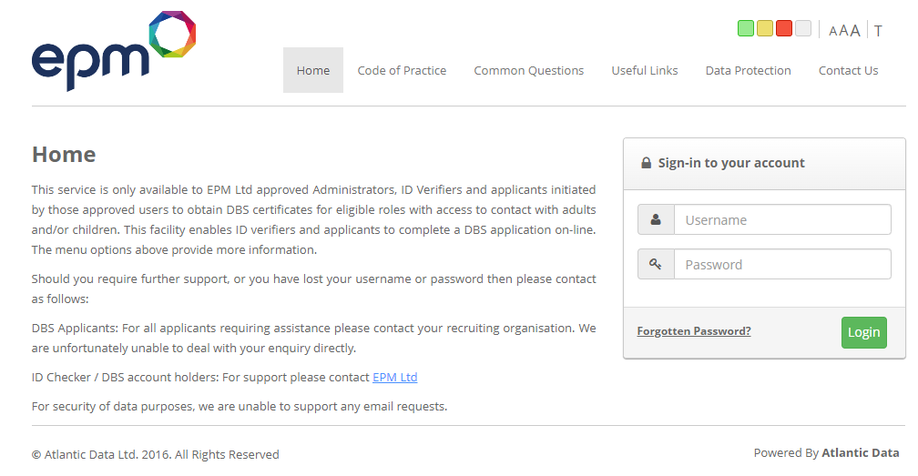
Log In Screen
From the Log in Screen you are able to log in and set up your DBS account.
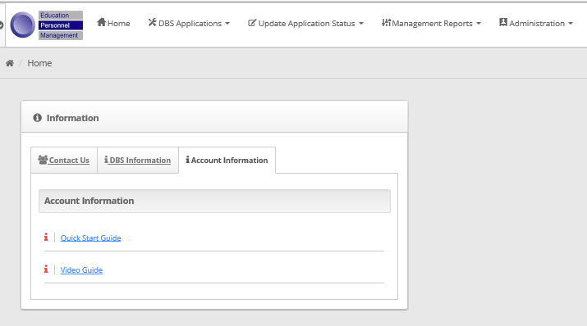


When you first use the DBS Portal you will be taken through an online guide showing you how to use the different features. However, if you need any assistance in the future you can access a Quick Start Guide and Video Guide via the Account Information tab.

Homepage
Once logged you can:
- Search for applicants
- Check the status of applications
- See any updates since you last logged in
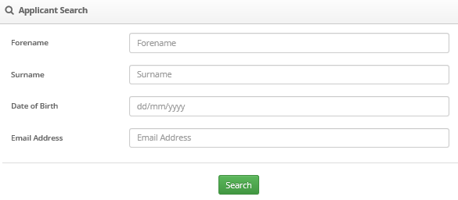

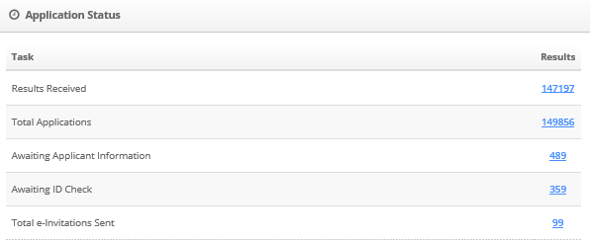
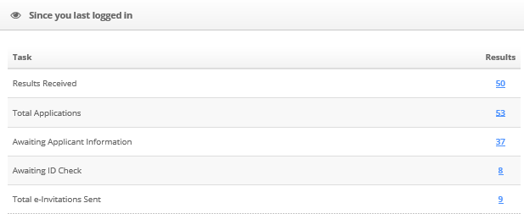

Processing a DBS Application
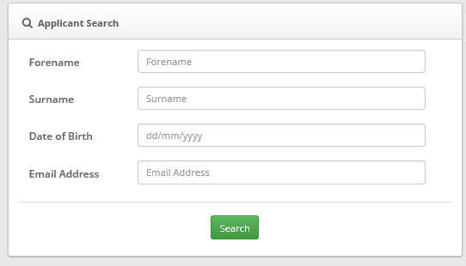
An application can be initiated by completing the following screen. Complete the Applicant Search details and click on Search.

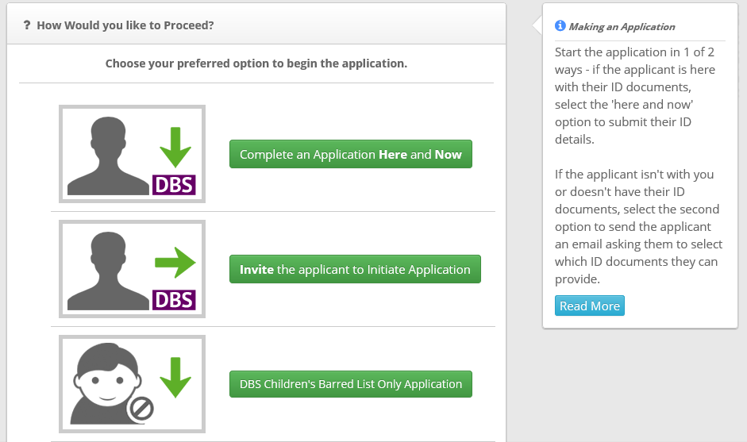
Select one of the three options available (normally ‘complete an application here and now’).

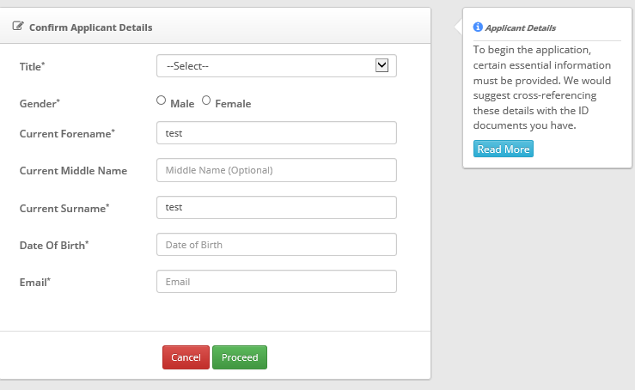
Using the ID provided by the applicant, complete the application following the instructions on the screen.

Once you have selected the ID from the list provided, completed all other necessary fields and selected the applicable job title, the portal will summarise the information the ID verifier has entered. Please ensure all information on the summary screen is correct before you submit as you will not be able to edit information once submitted.
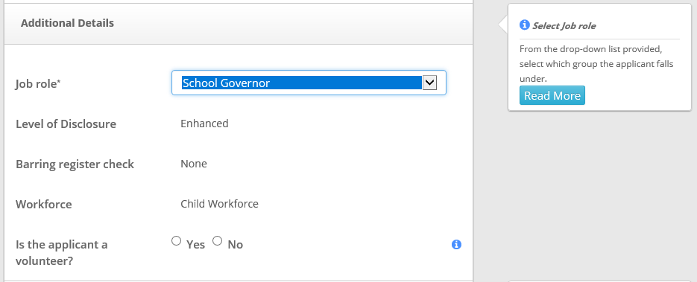
Please ensure you have selected the correct barred list status when selecting a volunteer role, as you are legally entitled to know the barred list status for those engaged in regulated activity only.

The example above shows this volunteer is not entitled to a barred list check.

Once the ID verifier has electronically signed to say the information provided is correct the applicant can either complete their part of the application ‘here and now’ or later.
Once the applicant has completed their part of the application, the DBS will be quality checked and then released for countersigning. It will then be sent to the DBS for processing. Applications can take between 2 – 10 days to be returned. However, there are some that can take 60 days plus. EPM can only escalate DBS applications that are over 60 days.
Once a result has been issued the ID verifiers will receive an email to prompt them to ask to see the issued DBS certificate from the applicant. You must then update the DBS portal to show you have seen the original.
The ID verifier should locate the individual in the applications menu, click on their name and then View Summary Result. You will need to re-enter your user name and password and follow the instructions.
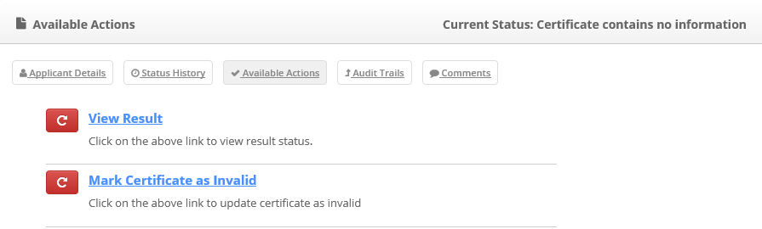

There will be an option for printing a copy of the summary for the personnel file.
This then completes the process in relation to DBS.
Please note if the result states ‘Certificate contains no information’ this means the certificate is clear. If the certificate states ‘Please wait to view applicant certificate’ this indicates a positive DBS.
You MUST see the applicant’s certificate as you will need to see the information held in order to complete a risk assessment which MUST be retained on the employee’s file. A risk assessment can be found in section B of www.epm.co.uk
We have a dedicated DBS Team who will be happy to assist you with any queries. They can be contacted on:
DBS Team
T: 01480 431993
T: 01480 483364
E: dbs@epm.co.uk

Appendix A: Reports

MAT Reports
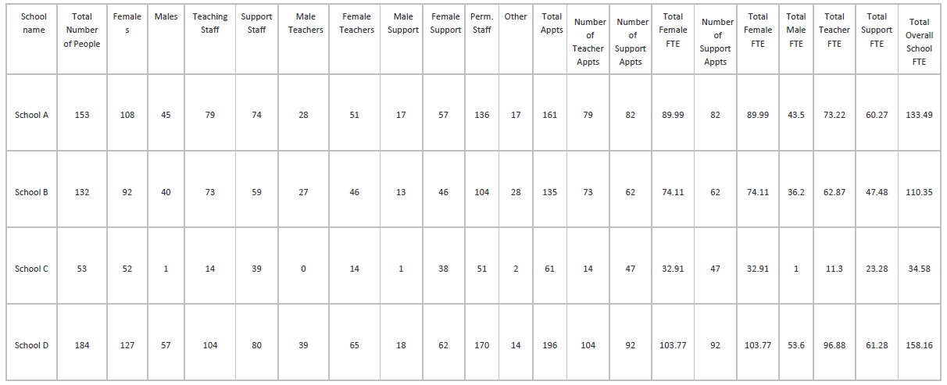
Multi-Academy Trust (MAT) Report: People and Appointment Summary Tab

Multi-Academy Trust (MAT) Report: Staff Turnover Summary Tab
EPM SCHOOL Number | Name | Total New Teachers  to the Academy Trust | Total New Support Staff  to the Academy Trust | Total Teaching Staff  leaving Academy Trust | Total Support Staff  leaving Academy Trust | Teachers transferred to another Academy Trust School | Support staff transferred to another Trust School
C345678 | School A | 0 | 0 | 18 | 21 | 0 | 1
C345679 | School B | 0 | 0 | 8 | 9 | 0 | 0
C345671 | School C | 0 | 0 | 2 | 24 | 0 | 0
C345672 | School D | 0 | 0 | 11 | 6 | 0 | 0
Multi-Academy Trust (MAT) Report: Absence Summary Tab
EPM School Number | School Name | Total Absence in  Reporting  Period  ex wkd | Total  Teaching  days lost  ex wkd | Total  Support  days lost  ex wkd | Total  Sickness  ex wkd | Total Long  Term  Sickness  ex wkd | Family  Related  Illness  ex wkd | Family  Related  Leave  PAID  ex wkd | Family  Related  Leave  UNPAID  ex wkd | Accident  At  Work  ex wkd | Accident  Outside  Work  ex wkd | Other  Absence  PAID  ex wkd | Other  Absence  UNPAID  ex wkd | Public  Service  ex wkd | Industrial  dispute  ex wkd | Annual  Leave  ex wkd | Instances of  recorded  absence  over 20 days
C345678 | School A | 23 | 23 | 0 | 0 | 0 | 0 | 23 | 0 | 0 | 0 | 0 | 0 | 0 | 0 | 0 | 0
C345679 | School B | 23 | 23 | 0 | 23 | 0 | 0 | 0 | 0 | 0 | 0 | 0 | 0 | 0 | 0 | 0 | 1
C345671 | School C | 110 | 110 | 0 | 0 | 0 | 0 | 110 | 0 | 0 | 0 | 0 | 0 | 0 | 0 | 0 | 0

Multi-Academy Trust (MAT) Report: Appointments & FTE Tab
EPM School  Number | School Name | EPM  Employee  Number | First  Name | Last  Name | Gender | Birth  Date | Age | Appointment  number | Budget  Code | Type | Job Family  Code | Job  Description | Effective  Date | Contract  Status  Code | FTE  Decimal
C345678 | School A |  |  |  | Female |  | 62 |  | 2000 | Teacher |  |  | 4/1/2016 | PERMANENT | 0.1
C345678 | School A |  |  |  | Female |  | 59 |  | 2000 | Support |  |  | 4/1/2016 | PERMANENT | 0.8
C345678 | School A |  |  |  | Female |  | 42 |  |  | Teacher |  |  | 4/1/2016 | PERMANENT | 0.8
C345678 | School A |  |  |  | Female |  | 37 |  | 2000122 | Teacher |  |  | 4/1/2016 | PERMANENT | 0.6
C345679 | School B |  |  |  | Female |  | 38 |  |  | Teacher |  |  | 4/1/2016 | PERMANENT | 1
C345679 | School B |  |  |  | Female |  | 45 |  | 2006430 | Teacher |  |  | 4/1/2016 | PERMANENT | 0.8
C345679 | School B |  |  |  | Female |  | 47 |  | 2006427 | Teacher |  |  | 4/1/2016 | PERMANENT | 1
C345679 | School B |  |  |  | Female |  | 65 |  | 2003028 | Support |  |  | 4/1/2016 | PERMANENT | 0.65
C345679 | School B |  |  |  | Female |  | 41 |  | 2000124 | Support |  |  | 7/1/2016 | PERMANENT | 0.81
C345679 | School B |  |  |  | Male |  | 58 |  | 2000124 | Support |  |  | 4/1/2016 | PERMANENT | 0.59
C345671 | School C |  |  |  | Female |  | 45 |  | 2000124 | Support |  |  | 7/1/2016 | PERMANENT | 0.87

Multi-Academy Trust (MAT) Report: Absences Detail Tab
EPM HR  Number | EPM School  Number | School Name | Employee Name | Gender | Teacher  Support | Cause of  Absence  Code | Description | Absence  End Date | Days Absent  recorded | Days in  Reporting  Period | Week Days in  Reporting Period
E987654 | C345671 | School C |  | Female | Teacher | 00 | General Illness | 9/27/2016 | 93 | 31 | 23
E967853 | C345671 | School C |  | Female | Teacher | ML | Maternity Leave | 8/31/2016 | 31 | 31 | 23
E789054 | C345671 | School C |  | Female | Teacher | ML | Maternity Leave | 8/31/2016 | 31 | 31 | 23
E890456 | C345671 | School C |  | Female | Teacher | ML | Maternity Leave | 8/31/2016 | 31 | 31 | 23
E236547 | C345672 | School D |  | Female | Teacher | ML | Maternity Leave | 8/31/2016 | 31 | 31 | 23
E349087 | C345672 | School D |  | Female | Teacher | ML | Maternity Leave | 8/31/2016 | 26 | 26 | 18
E234098 | C345672 | School D |  | Female | Teacher | ML | Maternity Leave | 8/31/2016 | 241 | 31 | 23
Multi-Academy Trust (MAT) Report: Academy Trust New Starters Tab
Report | Employee number | Gender | Employee Name | EPM School number | School Name | Appointment Date | Type | Job Description | Contract Status Code | Job Family Code
Multi-Academy Trust (MAT) Report: Academy Trust Transfers Tab
Report | Employee  No | Gender | Employee  Name | EPM  School  number | School  Name | Type | Job  Description | Contract  Status  Code | Resignation  Date | Resignation  Reason | Transferred  to | Destination  EPM  School  Number | Destination  School  Name | Destination  Job  Description | Destination  Job Type | Destination  Contract  Status  Code | Destination  Contract  Status  Code | New  Appt  Date
Transferred  Appts | E590467 | Male |  | C345672 | School D | Support | Teacher | PERMANENT | 31/08/2016  00:00:00 | TRANSMAT | Transferred  to | C345671 | School C | Deputy Head | Support | PERMANENT | PERMANENT | 9/1/2016

Multi-Academy Trust (MAT) Report: Academy Trust Leavers Tab
Report | Employee  number | Gender | Employee Name | EPM School  Number | School Name | Contract Status  Code | Type | Job Description | Resignation Date | Resignation  Reason | Current Employment Service Start | Length of  Service
Multi-Academy Trust (MAT) Report: Lookback Tab
PERIOD | EPM  School  Number | School  name | Total  Number  of  People | Females | Males | Teaching  Staff | Support  Staff | Male  Teachers | Female  Teachers | Male  Support | Female  Support | Perm  Staff | Other | Total  Appts | Number  of  Teacher  Appts | Number  of  Support  Appts | Total  Female  FTE | Number  of  Support  Appts | Total  Female  FTE | Total  Male  FTE | Total  Teacher  FTE | Total  Support  FTE | Total  Overall  School  FTE
31/05/16 | C345678 | School A | 154 | 110 | 44 | 77 | 77 | 26 | 51 | 18 | 59 | 136 | 18 | 162 | 77 | 85 | 91.73 | 85 | 91.73 | 42.5 | 71.29 | 63.01 | 134.3
31/01/16 | C345678 | School A | 154 | 110 | 44 | 76 | 78 | 26 | 50 | 18 | 60 | 138 | 16 | 162 | 76 | 86 | 91.32 | 86 | 91.32 | 42.5 | 69.89 | 64 | 133.89
30/06/16 | C345679 | School B | 129 | 90 | 39 | 70 | 59 | 26 | 44 | 13 | 46 | 101 | 28 | 132 | 70 | 62 | 71.89 | 62 | 71.89 | 35.2 | 59.67 | 47.46 | 107.13
31/08/16 | C345679 | School B | 132 | 92 | 40 | 73 | 59 | 27 | 46 | 13 | 46 | 104 | 28 | 135 | 73 | 62 | 74.11 | 62 | 74.11 | 36.2 | 62.87 | 47.48 | 110.35
31/08/16 | C345671 | School C | 53 | 52 | 1 | 14 | 39 | 0 | 14 | 1 | 38 | 51 | 2 | 61 | 14 | 47 | 32.91 | 47 | 32.91 | 1 | 11.3 | 23.28 | 34.58
31/12/15 | C345671 | School C | 55 | 54 | 1 | 14 | 41 | 0 | 14 | 1 | 40 | 55 | 0 | 62 | 14 | 48 | 33.68 | 48 | 33.68 | 1 | 11.7 | 23.65 | 35.35
31/12/15 | C345672 | School D | 188 | 127 | 61 | 109 | 79 | 41 | 68 | 20 | 59 | 177 | 11 | 200 | 110 | 90 | 104.32 | 90 | 104.32 | 57.8 | 100.58 | 62.25 | 162.83
29/02/16 | C345672 | School D | 185 | 127 | 58 | 108 | 77 | 40 | 68 | 18 | 59 | 172 | 13 | 197 | 108 | 89 | 103.18 | 89 | 103.18 | 54.4 | 99.58 | 58.76 | 158.34

Monthly Reporting
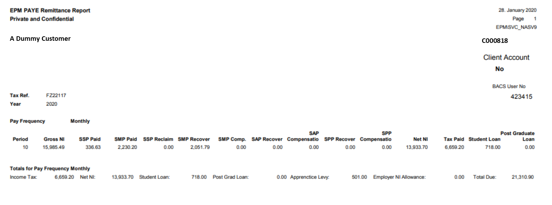
PAYE Remittance Report

Year to Date Pension
Private and Confidential
A Dummy Customer
Tax Ref. |  | HB19215
Year / Period |  | 2020 / 10
Pension Scheme |  | Name |  | EE Pens.  Contr. % | Date of  Birth | Leave  Date | NI Number | Pens.  Contr.  Salary | Pens.  Pay  (This  Period) | Pens.Pay  (Year to  Date) | EE's Pension  (This  Period) | EE's Pension  (Year to  Date) | Employer  Amount  (This  Period) | Employer  Amount  (Year to  Date) | FTE | Weeks
LGPS2678 - LGPS Office
 | 4 | Ives | Sam | 5.80 | 07/11/56 |  | AB******C | 17,053.92 | 0.00 | 0.00 | 0.00 | 0.00 | 0.00 | 0.00 | 31,371.00 | 43.70
LGPS2678 - LGPS Office
 | 10 | Ken | John | 6.80 | 23/04/82 |  | AB******C | 41,181.58 | 3,526.18 | 34,789.90 | 239.78 | 2,365.70 | 895.65 | 8,836.65 | 56,434.00 | 52.14
Total for Pension Scheme |  | Members in Scheme | 1 |  |  |  |  |  | 3,526.18 | 34,789.90 | 239.78 | 2,365.70 | 895.65 | 8,836.65
LGPS2678 - LGPS Office
 | 10 | Knott | Olivia | 8.50 | 27/10/67 |  | AB******C | 51,234.00 | 4,386.92 | 43,282.10 | 372.89 | 3,679.00 | 1,114.28 | 10,993.64 | 51,234.00 | 52.14
Total for Pension Scheme |  | Members in Scheme | 1 |  |  |  |  |  | 4,386.92 | 43,282.10 | 372.89 | 3,679.00 | 1,114.28 | 10,993.64
TPS - TPS Pension
 | 5 | Smith | Emma | 11.70 | 27/07/79 |  | AB******C | 0.00 | 0.00 | 33,964.60 | 0.00 | 3,973.85 | 0.00 | 5,597.35 | 81,515.00
Total for Pension Scheme |  | Members in Scheme | 1 |  |  |  |  |  | 0.00 | 33,964.60 | 0.00 | 3,973.85 | 0.00 | 5,597.35
TPS-1 - TPS Pension
 | 10 | Halls | Joe | 11.70 | 27/07/79 |  | AB******C | 0.00 | 7,330.00 | 36,650.00 | 857.61 | 4,288.05 | 1,735.74 | 8,678.71 | 81,515.00
Total for Pension Scheme |  | Members in Scheme | 1 |  |  |  |  |  | 7,330.00 | 36,650.00 | 857.61 | 4,288.05 | 1,735.74 | 8,678.71

Third Party Payments Report
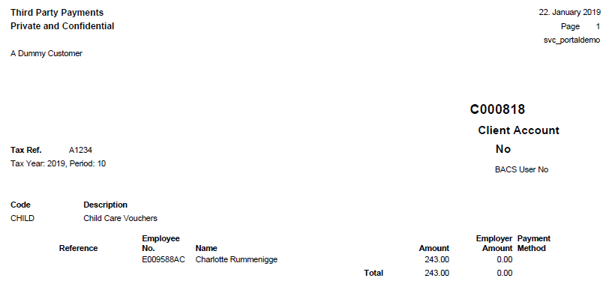

Academy Journal Report
Doc Type | Row | Doc Date | Nominal | Account | Value | Description | Year code | Period
ABCD | 01 | 31/05/2019 | DEFG9095 | ADM | 42207.08 | May 19 Admin Salaries | 2019/20 | 09
ABCD | 02 | 31/05/2019 | DEFG9095 | ADM | 2335.6 | May 19 Admin Salaries | 2019/20 | 09
ABCD | 03 | 31/05/2019 | DEFG9095 | ADM | 4,978.51 | May 19 Admin Salaries | 2019/20 | 09
ABCD | 04 | 31/05/2019 | DEFG9095 | CLN | 10428.58 | May 19 Ed Support Salaries | 2019/20 | 09
ABCD | 05 | 31/05/2019 | DEFG9095 | CLN | 254.77 | May 19 Ed Support Salaries | 2019/20 | 09
ABCD | 06 | 31/05/2019 | DEFG9095 | CLN | 988.98 | May 19 Ed Support Salaries | 2019/20 | 09
ABCD | 07 | 31/05/2019 | DEFG9060 | EDS | 26315.75 | May 19 Ed Support Salaries | 2019/20 | 09
ABCD | 08 | 31/05/2019 | DEFG9075 | EDS | 1321.94 | May 19 Ed Support Salaries | 2019/20 | 09
ABCD | 09 | 31/05/2019 | DEFG9195 | EDS | 3303.67 | May 19 Ed Support Salaries | 2019/20 | 09
ABCD | 10 | 31/05/2019 | DEFG9120 | PRE | 6369.25 | May 19 Teacher Salaries | 2019/20 | 09
ABCD | 11 | 31/05/2019 | DEFG9135 | PRE | 432.11 | May 19 Teacher Salaries | 2019/20 | 09
ABCD | 12 | 31/05/2019 | DEFG9150 | PRE | 837.56 | May 19 Teacher Salaries | 2019/20 | 09
ABCD | 13 | 31/05/2019 | DEFG9000 | TEA | 246495.68 | May 19 Teacher Salaries | 2019/20 | 09
ABCD | 14 | 31/05/2019 | DEFG9015 | TEA | 22195.76 | May 19 Teacher Salaries | 2019/20 | 09
ABCD | 15 | 31/05/2019 | DEFG9030 | TEA | 29014 | May 19 Teacher Salaries | 2019/20 | 09
ABCD | 16 | 31/05/2019 | AABB3300 |  | -233695.84 | Salaries May 19 | 2019/20 | 09
ABCD | 17 | 31/05/2019 | AABB3305 |  | -43135.05 | PAYE May 19 | 2019/20 | 09
ABCD | 18 | 31/05/2019 | AABB3305 |  | -49600.46 | NI May 19 | 2019/20 | 09
ABCD | 19 | 31/05/2019 | AABB3310 |  | -49419.19 | Pension Teaching Staff May 19 | 2019/20 | 09
ABCD | 20 | 31/05/2019 | AABB3315 |  | -14775.14 | Pension Support Staff May 19 | 2019/20 | 09
ABCD | 21 | 31/05/2019 | AABB3305 |  | -5274.00 | Student Loans May 19 | 2019/20 | 09
ABCD | 22 | 31/05/2019 | AABB |  | -63.00 | AEO Employee 1 | 2019/20 | 09

Monthly Rolling Absence Report
Employee | Date From | Date To | Absence Code | Absence Description | Notes
Henry , Melissa | 16-Jan-20 | 16-Jan-20 | UPL | Unpaid Parental Leave
Henry , Melissa | 20-Jan-20 | 31-Jan-20 | UPL | Unpaid Parental Leave
Blanc, Sarah | 05-Dec-19 | 02-Sep-20 | ML | Maternity Leave
Neeskens, Julia | 14-Jan-20 | 17-Jan-20 | AL | Annual Leave
Ronaldinho, Linda | 07-Jan-20 | 10-Jan-20 | 0 | General Illness | Went home at 10am
Baresi, Joy | 16-Jan-20 | 23-Jan-20 | 5 | Infectious/contagious | dr note to 25/02
Facchetti, Sarah | 16-Jan-20 | 21-Jan-20 | 0 | General Illness | doctors said xyz
Gunnarsson, Siobhan | 23-Jan-20 | 16-Apr-20 | ML | Maternity Leave
Kanu, Natalie | 20-Jan-20 | 20-Jan-20 | 0 | General Illness | 2 hours leave relating to dependant leave

Annual Reporting
Gender Pay Gap Report
Relevant Employees
Report produced on 17 Jan 2020 16:26:01
Report Period | Federation | Area | EPM School Number | School Name | EPM Employee Number | Gender | Relevant Employee | Full Pay Relevant Employee | Snapshot Bonus Paid | Previous 12 Month Bonus Paid | Snapshot Hours | Snapshot Ordinary Pay | Snapshot Casual Pay | Snapshot Total Pay | Snapshot Hourly Rate | Total Appointments | Casual Appointments
2019-12 | C009999 | 937 | C009999 | A Dummy Customer | E260350 | Female | Y | Y | 0 | 0 | 141.07 | 6792.92 | 0 | 6792.92 | 48.15 | 1 | 0
2019-12 | C009999 | 937 | C009999 | A Dummy Customer | E260531 | Female | Y | Y | 0 | 0 | 117.45 | 3431.8 | 0 | 3431.8 | 29.22 | 1 | 0
2019-12 | C009999 | 937 | C009999 | A Dummy Customer | E260569 | Female | Y | Y | 0 | 0 | 160.95 | 4269.5 | 0 | 4269.5 | 26.53 | 1 | 0

Relevant Appointments
Report Period | Federation | Area | EPM School Number | School Name | EPM Employee Number | Appointment Number | Contract Status | Job Description | Unpaid Leave | Effective Date | End Date | Appointment Days In Period | Days In Period | Contracted Hours | Calculated Hours | Calculated Amount | Casual Hourly Rate | Weekly Hours | Supply Hours Daily
2019-12 | C009999 | 937 | C009999 | A Dummy Customer | E260350 | D334412 | PERMANENT | Headteacher | No | 01/03/2019 | 31/03/2019 | 31 | 31 | 141.07 | 141.07 | 0 | 0.00 | 32.43 | 6.49
2019-12 | C009999 | 937 | C009999 | A Dummy Customer | E260531 | D334743 | PERMANENT | Chief Operating Officer | No | 01/03/2019 | 31/03/2019 | 31 | 31 | 117.45 | 117.45 | 0 | 0.00 | 27 | 6.49
2019-12 | C009999 | 937 | C009999 | A Dummy Customer | E260569 | D334785 | PERMANENT | Chief Finance Officer | No | 01/03/2019 | 31/03/2019 | 31 | 31 | 160.95 | 160.95 | 0 | 0.00 | 37 | 6.49
Hourly Analysis
Federation | Gender | Median Gender Hourly Rate | Median Gender Hourly Gap Percentage | Mean Gender Hourly Rate | Mean Gender Hourly Gap Percentage
C009999 | Female | 29.22 |  | 34.63
Bonus Analysis
Federation | Gender | Gender Bonus Count | Gender Head Count | Gender Bonus Percentage | Median Gender Bonus Gap Percentage | Percentile Disc Gender Bonus | Mean Gender Bonus Gap Percentage | Mean Gender Bonus

Rolling Annual Absence Report
Rolling Annual Absence Report
No. | C000818
Name | A Dummy Customer
Absence Period | 22/01/20 to 23/01/19
Employee No. | Name | NI Number | Date of Birth | Description of Absence | Absence  Sub-category | Absence Addl. Text | Notes | No. of days Absent | From Date | To Date | Type | Full/Part Time
E983751 | John Smith | AB******C | 23/09/67 | Annual Leave |  |  |  | 3 | 30/10/19 | 01/11/19 | Support | Full
 |  |  |  | Annual Leave |  |  |  | 4 | 24/12/19 | 27/12/19 | Support | Full
E907293 | Lucy Jones | AB******C | 24/09/78 | Absent paid with permission |  |  | Take son to hospital | 1 | 13/03/19 | 13/03/19 | Teacher | Full
 |  |  |  | General Illness |  |  | Flu, going to GP AM, in later | 1 | 19/03/19 | 19/03/19 | Teacher | Full
 |  |  |  | Absent paid with permission | Childcare within policy |  | Children sick. No Childcare | 1 | 07/06/19 | 07/06/19 | Teacher | Full
 |  |  |  | Absent paid with permission |  |  | Interview | 1 | 02/07/19 | 02/07/19 | Teacher | Full
E998002 | Rosie McGuire | AB******C | 01/06/66 | General Illness |  |  | Swollen glands | 1 | 01/04/19 | 01/04/19 | Teacher | Full
E911679 | Jack Roberts | AB******C | 01/09/63 | Absent paid with permission | Bereavement |  | Father passed away | 1 | 16/07/19 | 16/07/19 | Support | Part
 |  |  |  | Absent paid with permission |  |  |  | 2 | 17/12/19 | 18/12/19 | Support | Part
E956293 | Lisa Bennett | AB******C | 05/01/59 | General Illness |  |  | Not well | 1 | 18/03/19 | 18/03/19 | Support | Full
 |  |  |  | General Illness |  |  | Upset stomach | 5 | 02/05/19 | 06/05/19 | Support | Part
 |  |  |  | General Illness | Migraine |  | In at 11.06am | 1 | 04/10/19 | 04/10/19 | Support | Part
 |  |  |  | Absent paid with permission | Medical Appointment |  | GP Appointment | 1 | 10/12/19 | 10/12/19 | Support | Part

SWFC Report
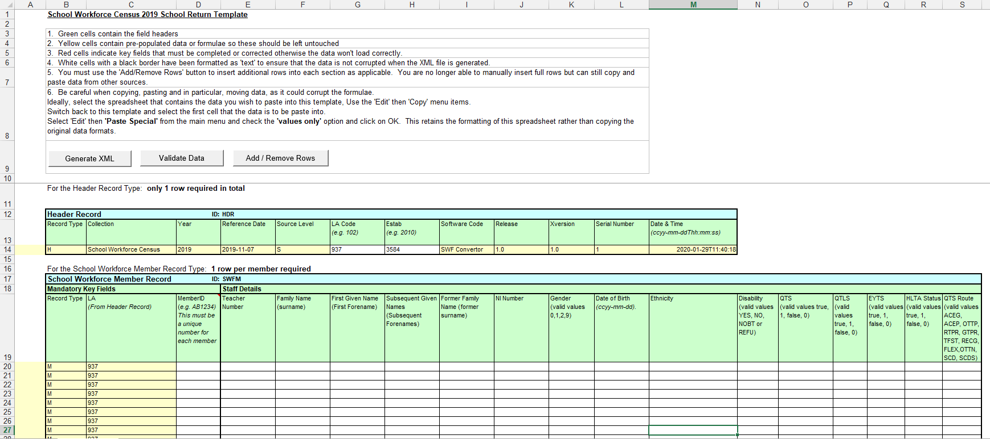

EPM data will cover:
- School workforce member record (except disability, HLTA status)
- Contract or service group record type (except daily rate, destination)
* Note the new post classifications of 'apprentice teacher’ will only be populated where the ‘contract additional text code’ on the portal is populated to indicate an apprentice teacher (ode APPN)
- Role record type
- Role additional payments record type
- Absence record type (for EPM Payroll Schools only)
- Qualification record type
- Reason for leaving (Reason for leaving will be listed as ‘other’ unless one of the alternative reasons is recorded on the EPM portal)

Pre-validation Reports
Costings Report
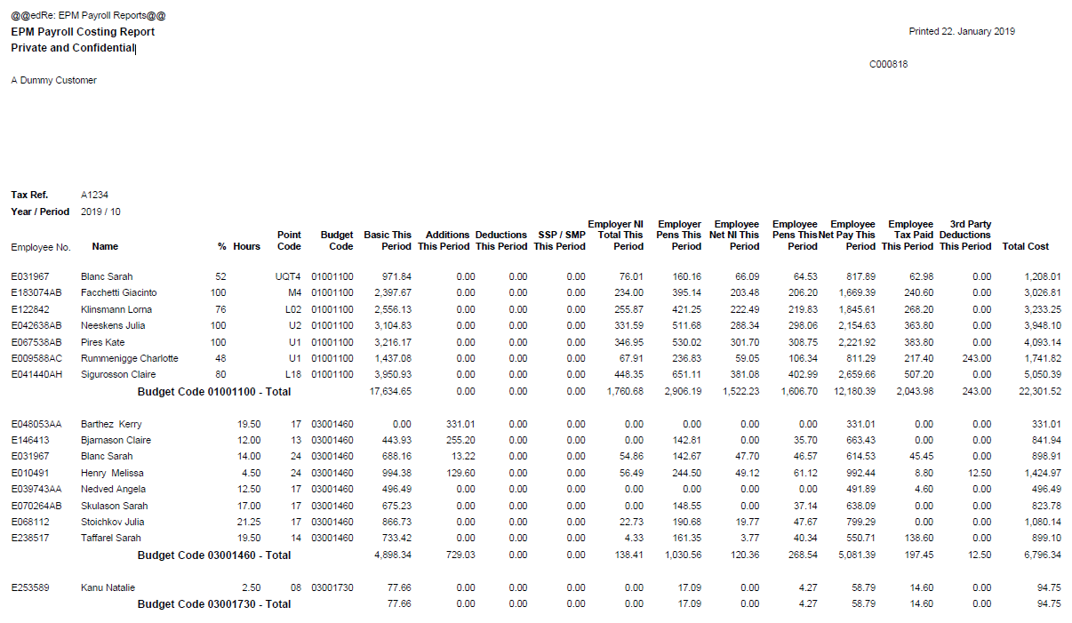

Previous Pay Comparison Report
A Dummy Customer
Year / Period | 2020 / 10
Tolerance | 5%
LEGEND: | Postive Diff. | Negative Diff.
 |  | Gross Pay  Diff. % | Net Pay  Diff. % | Current  Period  Gross Pay | Current  Period  Net Pay | Previous  Period  Gross Pay | Previous  Period  Net Pay | Budget  Code 1 | Budget  Perc. 1 | Budget  Hours 1 | Budget  Code 2 | Budget  Perc. 2 | Budget  Hours 2 | Budget  Code 3 | Budget  Perc. 3 | Budget  Hours 3 | Budget  Code 4 | Budget  Perc. 4 | Budget  Hours 4
Employee No. | Name
E991122 | Baker, Joe | 106.70 | 93.00 | 1,390.29 | 1,102.61 | 672.77 | 571.19 |  | 0.00 | 0.00 |  | 0.00 | 0.00 |  | 0.00 | 0.00 |  | 0.00 | 0.00
E900082 | Bennett, Carole | 100.00 | 95.00 | 730.60 | 555.54 | 365.30 | 284.87 |  | 0.00 | 0.00 |  | 0.00 | 0.00 |  | 0.00 | 0.00 |  | 0.00 | 0.00
E990225 | Coe, Jane | 14.50 | 11.10 | 1,673.19 | 1,318.27 | 1,461.20 | 1,186.41 |  | 0.00 | 0.00 |  | 0.00 | 0.00 |  | 0.00 | 0.00 |  | 0.00 | 0.00
E991176 | Foy, Robert | -20.00 | -16.50 | 1,780.85 | 1,400.44 | 2,225.42 | 1,676.36 | 1001100 | 0.00 | 100.00 |  | 0.00 | 0.00 |  | 0.00 | 0.00 |  | 0.00 | 0.00
E956721 | Askew, Lisa | -14.70 | -10.50 | 1,488.96 | 1,262.68 | 1,746.26 | 1,411.15 | 3001460 | 25.00 | 100.00 |  | 0.00 | 0.00 |  | 0.00 | 0.00 |  | 0.00 | 0.00
E965758 | Simpson, Johnathan | 25.00 | 18.20 | 2,819.68 | 1,885.71 | 2,255.74 | 1,595.38 | 1001100 | 0.00 | 100.00 |  | 0.00 | 0.00 |  | 0.00 | 0.00 |  | 0.00 | 0.00
E957463 | Tranter, Ben | 0.00 | 97.50 | 2,968.08 | 3,753.14 | 2,968.08 | 1,900.54 | 1001100 | 0.00 | 100.00 |  | 0.00 | 0.00 |  | 0.00 | 0.00 |  | 0.00 | 0.00

EPM Payroll Summary Report
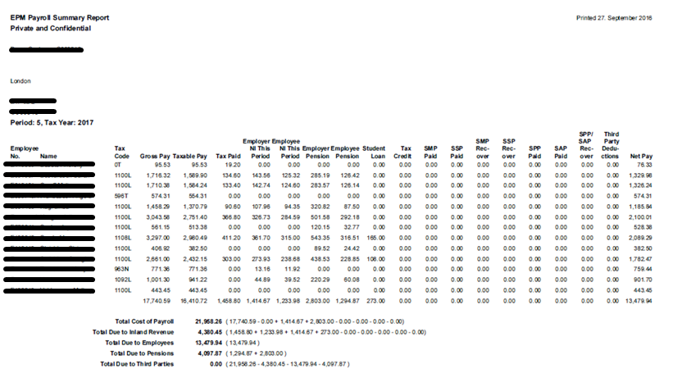

Example ePayslip
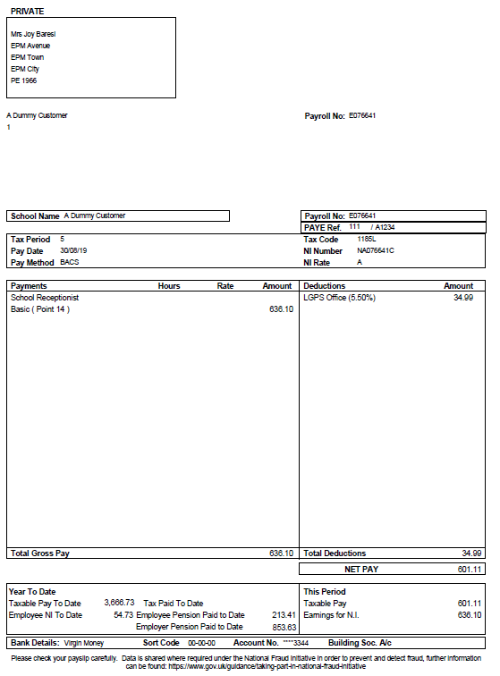

Example P60
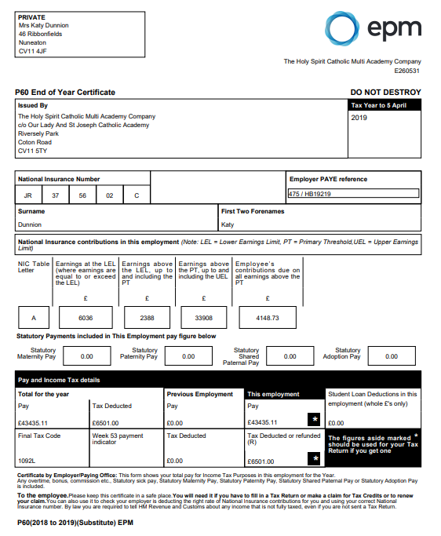
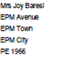



Variance Report
Employee No | Employee | Appointment No | Job Title | Period | Cost Code | Variance Code | Variance Description | Month/Year | Days Worked | Units | Rate | Total
E031967 | Blanc, Sarah | D150953 | Higher Level Teaching Assistant | 1 Jan 2020 | 3001460 | EXPENSES | Bus. expenses with receipt | Dec-19 | 0 | 0 | 0 | 51.5
E031967 | Blanc, Sarah | D150953 | Higher Level Teaching Assistant | 1 Jan 2020 | 3001460 | OTRATE | Overtime (F/R) | Dec-19 | 0 | 2 | 13.22 | 26.44
E031967 | Blanc, Sarah | D150953 | Higher Level Teaching Assistant | 1 Jan 2020 | 3001460 | OTRATE3 | Overtime (1.78) | Dec-19 | 0 | 2.5 | 23.532 | 58.83
E031967 | Blanc, Sarah | D150953 | Higher Level Teaching Assistant | 1 Jan 2020 | 3001460 | OTRATE | Overtime (F/R) | Jan-20 | 0 | 5.2 | 13.22 | 68.744
E048053 | Barthez , Kerry | D099869 | Teaching Assistant | 1 Jan 2020 | 3001460 | EXPENSES | Bus. expenses with receipt | Dec-19 | 0 | 0 | 0 | 11.98
E048053 | Barthez , Kerry | D099869 | Teaching Assistant | 1 Jan 2020 | 3001460 | OTRATE2 | Overtime(1.33) | Dec-19 | 0 | 4.2 | 14.69 | 61.69674
E048053 | Barthez , Kerry | D099869 | Teaching Assistant | 1 Jan 2020 | 3001460 | OTRATE1 | Overtime (1.5) | Nov-19 | 0 | 3.4 | 16.53 | 56.202
E076641 | Baresi, Joy | D148822 | School Receptionist | 1 Jan 2020 | 5001200 | OTRATE1 | Overtime (1.5) | Nov-19 | 0 | 10 | 13.74 | 137.4
E076641 | Baresi, Joy | D148822 | School Receptionist | 1 Jan 2020 | 5001200 | MILEAGE | Bus. mileage at/under 45p p/m | Jan-20 | 0 | 0 | 0 | 45
E145089 | Finnbogason, Anthony | D148869 | Clerk to Governors | 1 Jan 2020 | 1200 | OTRATE1 | Overtime (1.5) | Dec-19 | 0 | 2 | 13.74 | 27.48
E146413 | Bjarnason, Claire | D148316 | Teaching Assistant | 1 Jan 2020 | 3001460 | EXPENSES | Bus. expenses with receipt | Dec-19 | 0 | 0 | 0 | 9
E146413 | Bjarnason, Claire | D148316 | Teaching Assistant | 1 Jan 2020 | 3001460 | EXPENSES | Bus. expenses with receipt | Dec-19 | 0 | 0 | 0 | 110.99
E146413 | Bjarnason, Claire | D148316 | Teaching Assistant | 1 Jan 2020 | 3001460 | OTRATE | Overtime (F/R) | Dec-19 | 0 | 4.8 | 10.26 | 49.248
E146413 | Bjarnason, Claire | D148316 | Teaching Assistant | 1 Jan 2020 | 3001460 | OTRATE4 | Overtime (2) | Dec-19 | 0 | 5.3 | 20.52 | 108.756
E146413 | Bjarnason, Claire | D148316 | Teaching Assistant | 1 Jan 2020 | 3001460 | OTRATE2 | Overtime(1.33) | Nov-19 | 0 | 2.6 | 13.677 | 35.55916
E146413 | Bjarnason, Claire | D148316 | Teaching Assistant | 1 Jan 2020 | 3001460 | OTRATE1 | Overtime (1.5) | Dec-19 | 0 | 11.5 | 15.39 | 176.985

