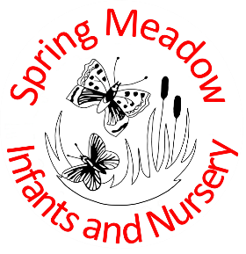

Spring Meadow Infant and Nursery School
High Barns
Ely Cambridgeshire
CB7 4RB
Tel: 01353 664742
Email: office@springmeadow.cambs.sch.uk
Website: www.springmeadow.cambs.sch.uk

Vacancy: School Cleaner

School Cleaner 15 Hours per week – 3:00pm – 6:00pm (occasional overtime available)
- Monday - Friday
- Spring Meadow Infant and Nursery School
We are currently recruiting passionate and hardworking people to join our cleaning team. We are looking for an individual who takes great pride in offering an excellent service when cleaning. Welcome people who strive always for the best! We offer a benefits package which includes:
- Free parking
- Overtime available
- Contributory pension scheme
Main Responsibilities
Your key responsibilities will include:
- Working as part of our cleaning team to keep environments safe and hygienic across the school
- Polishing, sweeping, mopping, dusting, and vacuuming and cleaning toilet facilities. This includes hard and carpeted floors, skirting, windowsills, desks, and other hard surfaces
- Emptying bins and removing rubbish from the area
- Working within a designated area
- Ensuring your area is cleaned to a high standard daily
- Attend Training Days and keep upskilled and aware of changes in Health & Safety.
- Participate in the annual deep clean of the school
- Comply with Safeguarding Legislation and confidentiality. Including receive a DBS check, due to the nature of the location of the role.

Ideal Candidate
Do you:
- Have the ability to work independently, but as part of a team and pay attention to detail
- Enjoy working in a hands-on role
- Have a flexible approach to working
- Comply with Health & Safety regulations
- Willingness to participate in training to support the role
- Enjoy seeing results from your work
Job Type: Part-time, permanent: Monday to Friday, 40 weeks per year. Salary: Level 1A Point 1
Closing Date: Midday Friday 2ndOctober 2026
Interviews: Week commencing Monday 5th October 2026
Please apply by completing the Support Staff Application on our website and return to the office@springmeadow.cambs.sch.uk.

